Name(s) ________________________________________________ Spanish American War _____/20
Unit 5: Spanish American War: “Remember the Maine!” http://bit.ly/yellowjournalism
Objective: Create your own digital Yellow Journalism newspaper that covers the sinking of the USS Maine, a key event that led to the Spanish American War.
Guidelines: You will be creating a digital newspaper. You can work in pairs or on your own. You will have 2 classes to work on this project. If you need additional time, you can work on it at home, or you can arrange to work on it after school.
Directions:
1) Watch the videos about Yellow Journalism & the USS Maine (in Schoology & on our Class Website)
2.) Use the Evernote link to read about the sinking of the USS Maine in Havana Harbor from primary sources.
- Background Info: Yellow Journalism
- USS Maine
3) Complete the 5 W’s graphic organizer on the back of this handout. This should include all the important information you discover while researching the events surrounding the USS Maine.
4) Create a Yellow Journalism newspaper about the USS Maine that includes the following elements:
- A sensational headline …remember, you want to sell the MOST newspapers!
- A quote from an actual person from the USS Maine (primary source)
- A short summary of the event
- An image of the USS Maine (primary source)
- A political cartoon about the USS Maine (or The Spanish American War)
- The view-point of a yellow journalist (exaggerated, excited reporting)

Options for creating your digital newspaper:
- Use the Google Docs Newspaper Templates or Word Document Newspaper Templates to complete this assignment. Click here for Google Doc Templates (also available in Schoology)

- Create a Prezi using the premade Newspaper Template available in Prezi.
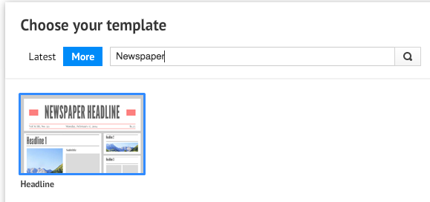

  - Select “New Prezi” > Type “Newspaper” into the search bar

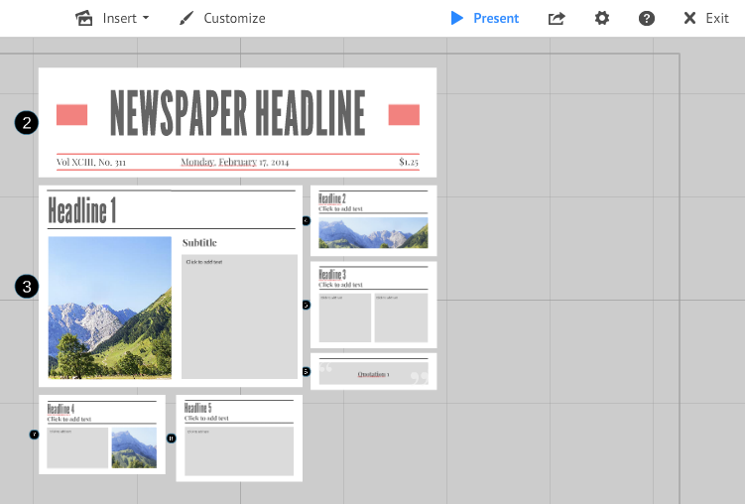
  - If you decide to make a Prezi, make sure to share it with your partner before you start working so that you can both work on the same project at the same time!

  - Make sure BOTH partner NAMES are in the title of the project when you submit the link in Schoology

  - Remember to share it with brownb@fccps.org before submitting it.

SUBMITTING YOUR ASSIGNMENT: Turn this assignment in through Schoology. Ether upload the Google Docs link, Prezi shared link, or upload your Word Document. Save your document as: Your Name Yellow Journalism
SCHOOLOGY TURN-IN DIRECTIONS:
- In the Schoology Assignment, Click “Submit Assignment”
- Select “Create”
- Click on the Hyperlink Symbol -
- Paste the Google Doc or Prezi link (after it has been shared with brownb@fccps.org)
- Title it with BOTH PARTNER NAMES, yellow journalism (Ex: Courtney and Brooke Yellow Journalism)
- Click “Submit”
You will be assessed on the information you find to answer the items below:

______ /2 Sensational headline shows creativity and connects to the main idea
Creativity (1 pt.) Main Idea (1 pt.)
______/2 Quote from primary source is interesting connected to the main idea
Interesting (1 pt.) Main Idea (1 pt.)
______/2 Summary is written with main idea/supporting details and is grammatically correct.
Content (1 pt.) Grammar (1 pt.)
______/2 The image selected relates to the summary and is a primary source.
Related (1 pt.) Primary Source (1 pt.)
______/2 Political Cartoon that relates to the event/war and is a primary source.
Related (1 pt.) Primary Source (1 pt.)
______/2 View point of a yellow journalist is evident in the writing style and images.
Content (1 pt.) Grammar (1 pt.)
______/8 Project reflects effort and understanding of Yellow Journalism, the sinking of the USS Maine, and the Spanish American War
______/20 Total Score

Graphic Organizer:
Who?
What?
Where?
When?
Why?
How?

