Name: ___________________________________ World War I

Introduction: Key Terms to Know

Word | Definition | What it looks like…draw an image
Militarism

Alliances

Nationalism

Imperialism

What does the last missing “A” stand for in the “Mania” acronym? _______________________

A. Reasons for United States Involvement in World War I

- America’s inability to stay _______________________. The U.S. joined the Allies and entered the war on _______________________.
- German Submarine Warfare: On May 7, 1915, the sinking of the British ocean liner RMS _________________________.
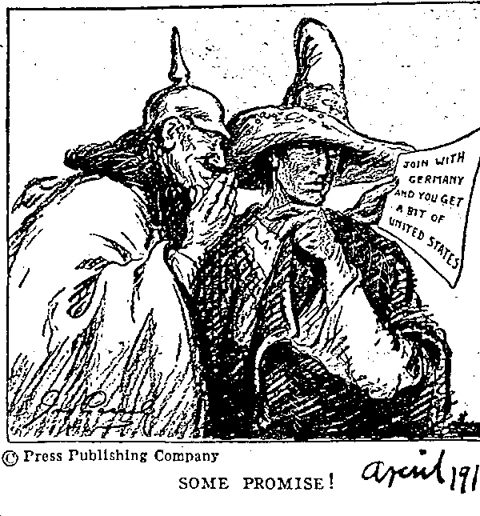
- The United State’s _________________________ and __________________________ ties with Great Britain.
- Germany tries to persuade ___________________ to declare war on the United States with the ________________________________ telegram.

B. Atlas Activity: Allied vs. Central Powers
- Label and shade in the nations that made up the Allied Powers –
- Label and shade in the nations that made up the Central Powers -

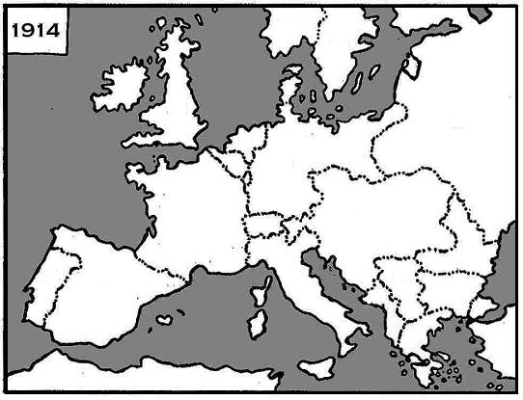
The Allied Powers | The Central Powers
- The British Empire  - France  - Russia  - Serbia  - Belgium  - The United States | - German Empire  - Austro-Hungarian Empire  - Bulgaria  - Ottoman Empire (Turkish)

- United States Leadership as the War Ended
- At the end of World War I, President Woodrow Wilson prepared a peace plan known as the ______________ that called for the formation of the _______________________________, a peacekeeping organization.
- U.S. President Woodrow Wilson pushed for a peace treaty that did ______ punish Germany for the war, but the European powers did not agree…
- The United States Senate did _______ ratify the Treaty of Versailles because of a desire to resume prewar _______________________.
- The United States did ________ become a member of the League of Nations.

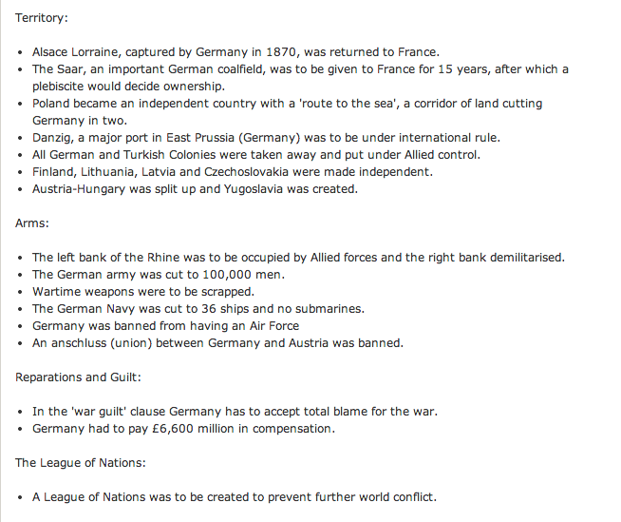
The Treaty of Versailles:
Lands Lost

Reduced Military

War Guilt & Reparations

League of Nations

Looking to the Future: Did the outcome of WWI and the Treaty of Versailles almost guarantee that Europe would be fighting another World War in the near future? EXPLAIN your opinion.

____________________________________________________________________________________________________________________________________________________________________________________________________________________________________________________________________________________________________________________________________________________________________
WWI – Key Facts to Know to Better Understand WWII…but not on the test
When did Germany “unify” declaring Wilhelm I, King of Prussia to be the new German Emperor? (Kaiser = Emperor)

What side of the war did Japan fight for?
In 1919, why did Japanese leaders leave the Paris Peace Conference frustrated and angry with its former allies?

What “mandates” (colonies) in Asia and the South Pacific, were given to Japan in the Treaty of Versailles?

These 5 treaties officially ended WWI. What country did each of the treaties deal with?

- Treaty of Versailles, June 28, 1919 - ___________________________________________
- Treaty of Saint-Germain, September 10 - ______________________________________
- Treaty of Neuilly, November 27, 1919 - ________________________________________
- Treaty of Trianon, July 4, 1920 - _______________________________________________
- Treaty of Sèvres, August 10, 1920 - ____________________________________________
Why was Russia not a part of the Paris Peace Conference in 1919?
____________________________________________________________________________________________________________________________________________________________________________________________________________________________________________________________________________________________________________________________________________________________________

Explain why Poland “disappeared” from the map in the late 18th century (1772-1795) then “reappeared” after WWI? ________________________________________________________________ ___________________________________________________________________________________________________________________________________________________________________________________________________________________________________________________________________________

What happened to Kaiser Wilhelm II?
_________________________________________________________________________________________ _________________________________________________________________________________________

