The New York World
News like never before!
$1.50

Wednesday, January 14, 2014

Revenge At Last
America just can’t seem to win this war.

Britain and Spain Declare Combined War on America!  Sneha Parthasarathy and Tessa Boneau  U.S.S Maine - At 9:40 P.M. on the 15 of February, 1898, a ship exploded, but not for the reasons you might think. Here is the surprising truth.  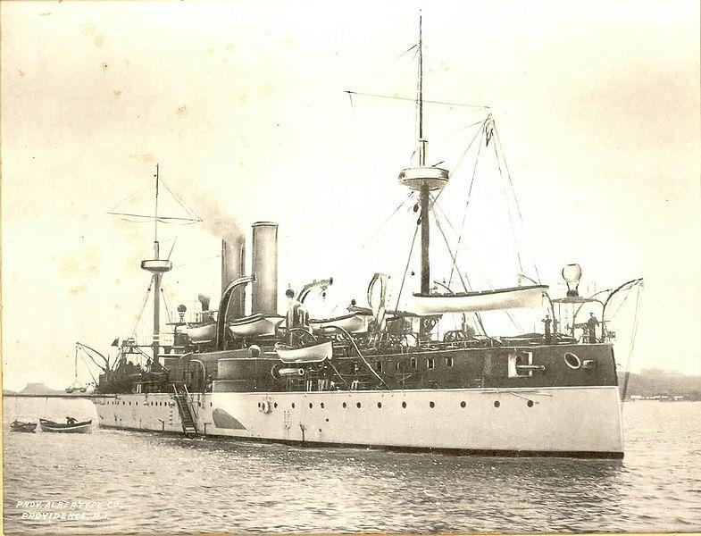  A picture of the USS Maine  The U.S. Naval Court has said that “ it was blown up because of a mine,” but we know the truth! After years of waiting, Britain has finally decided to claim back their former territory, America. They have allied with the legendary Spain, apparently willing to put back their long history of being enemies, all because of America, the Golden Land. We all know that America has all the resources both empires have | ever wanted. They are plotting to overthrow President McKinley and take over America. But will we stand for this?!  Remember the Maine!  The Maine will be remembered as a tragic, but revolutionary action forever. The U.S.S. Maine was second-class battleship that took 9 years to build, and was the first ship to be completely built in an American Naval Yard with all American products. Due to some riots in 1897, the United States sailed the Maine into Havana Harbor, Cuba. All of a sudden, on one sunny day, a explosion rang through the air. Everything turned chaotic. In fact, one of the 261 fatalities died in shock.  Quote: " I was enclosing my letter in its envelope when the explosion came. It was bursting... and crashing roar of immense volume, largely metallic in character... the electric lights went out. Then there was intense blackness and smoke." By Captain Sigsbee  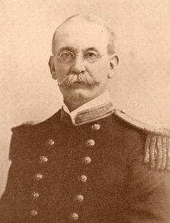 | 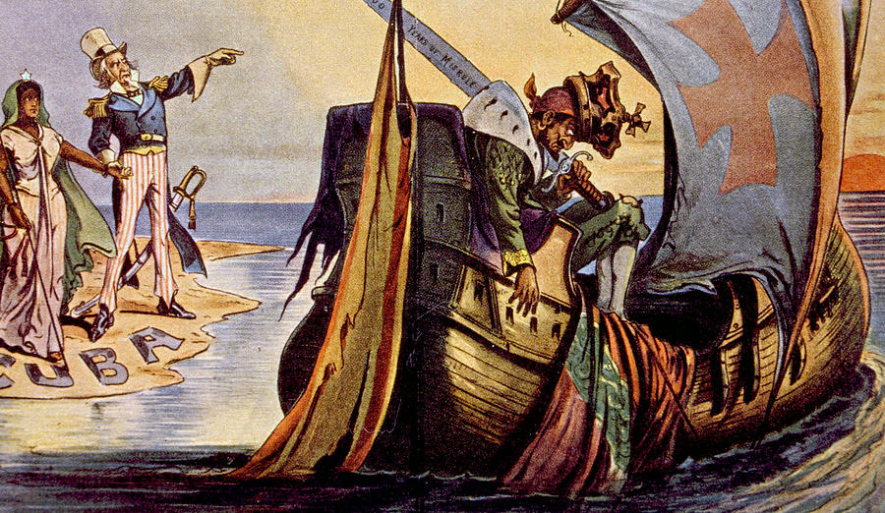  Spanish American War  By now, Congress has little doubt that Spain was responsible, and the American Public has given in to hysteria. But why would England join them against us? If you can remember, on April 19, 1775, a war was declared against England. America won with many casualties. The United Kingdom has looked for revenge ever since. Now, with Spain’s majestic Naval Fleet, they finally have a chance. With the brutal power of Spain and the wit of England, America has little chance of winning this war. But maybe, with Teddy Roosevelt and Captain Dewey, we can pull it off. After all, “Wars may be fought with weapons, but they are won by men. It is the spirit of men who follow and of the man who leads that gains the victory.”  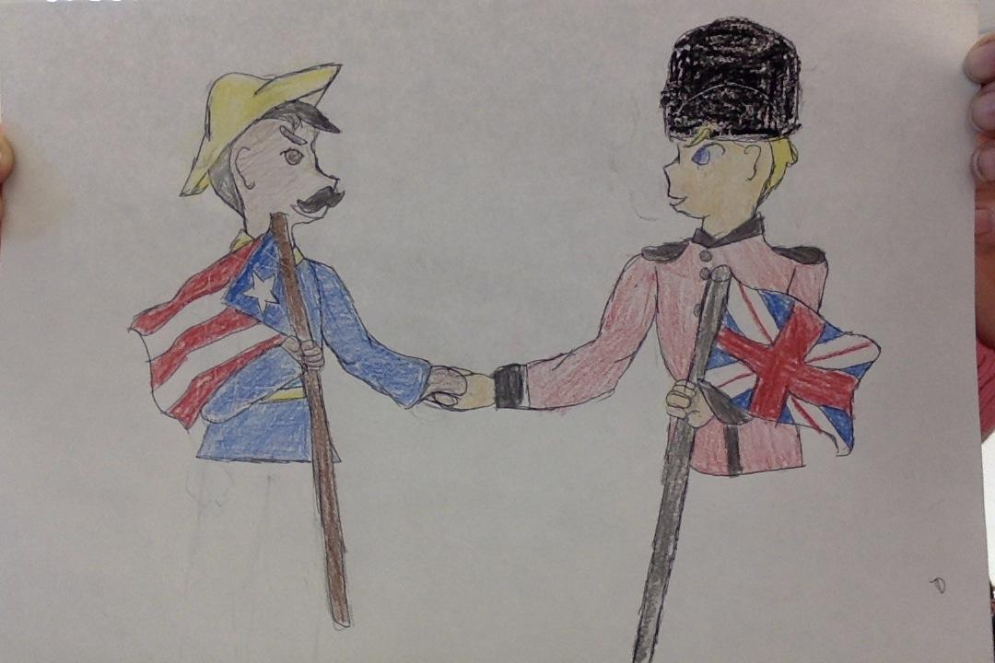  Drawn by: Tessa Boneau & Sneha Parthasarathy

