Name: _____________________________ Spanish American War A - B

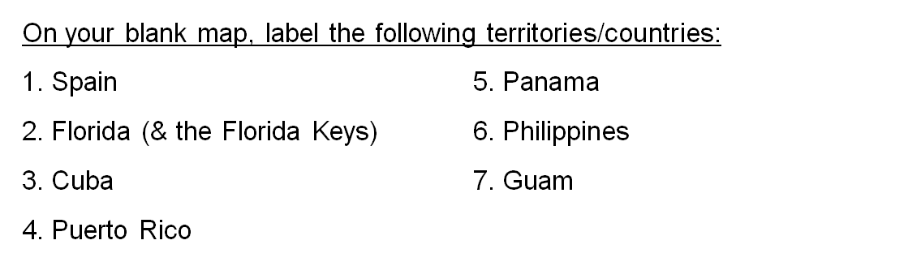
Intro: Atlas Activity

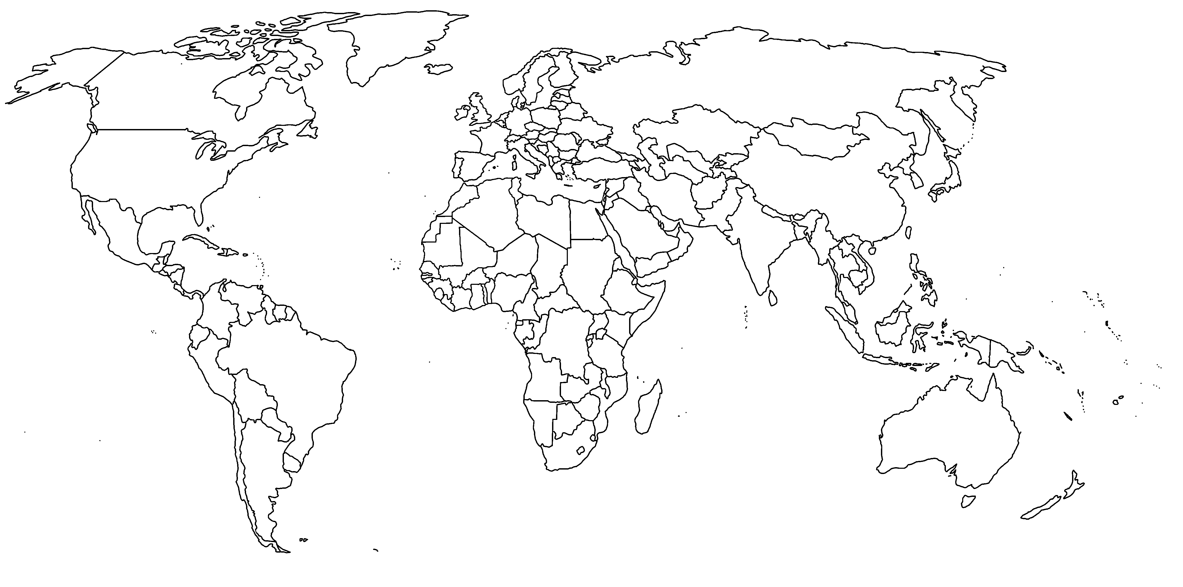

Map of Caribbean/Central America: Map of the Pacific Islands:
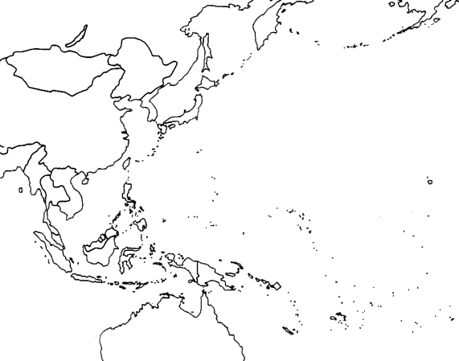
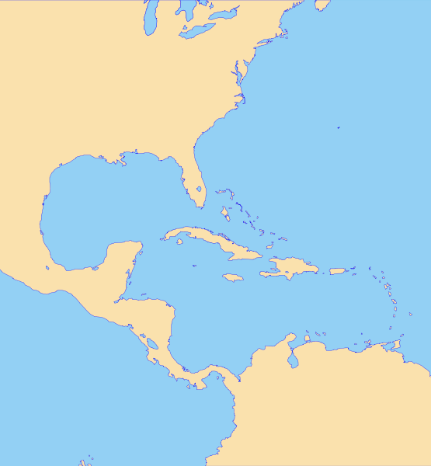

(You are going to need an atlas for this one!)

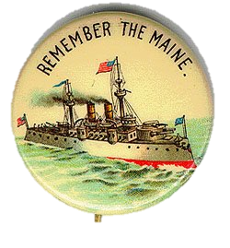
- Reasons for the Spanish American War:
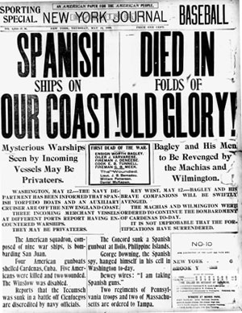
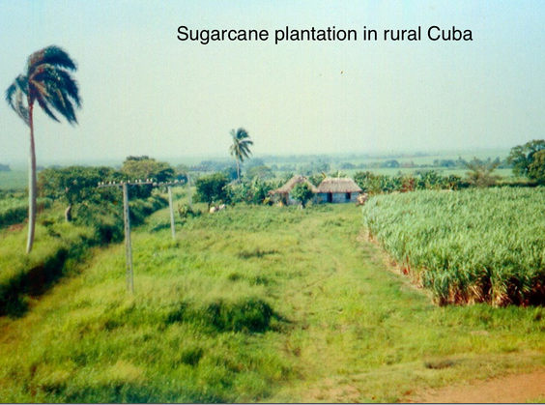
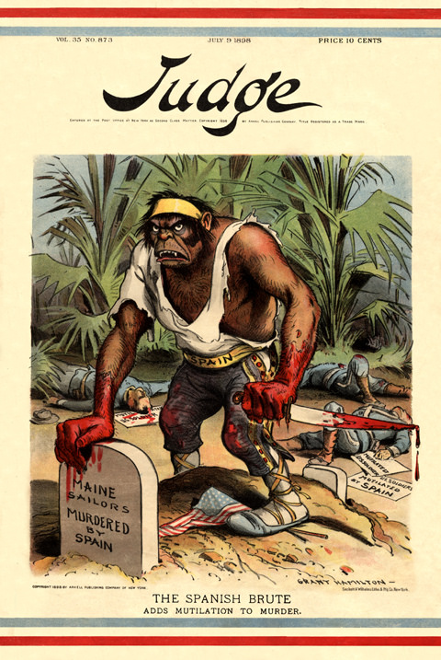

- Protection of American __________________ _________________ in Cuba.
- American support of Cuban ______________ to gain independence from ______________.
- Rising tensions between Spain and the United States as a result of sinking of the _____________________ in the Havana Harbor.
- Exaggerated ________ reports of events with ____________ journalism.

- Results of the Spanish American War:
- The United States emerged as a _______________________________.
- Cuba gained independence from ___________. (but as a temporary U.S. protectorate)
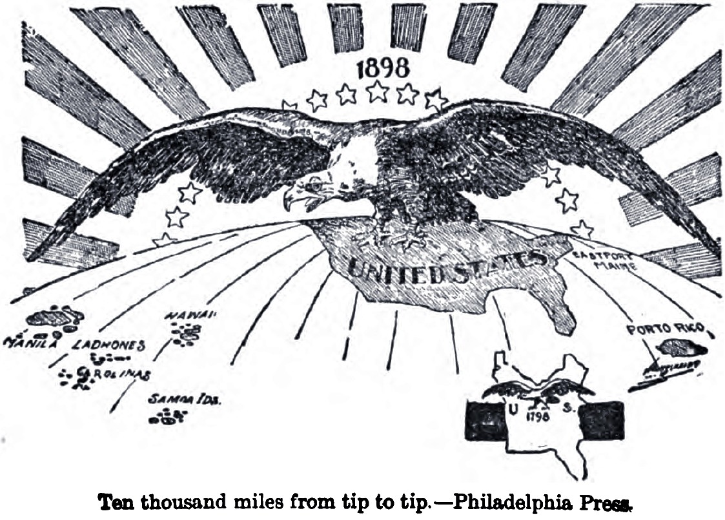
- The United States gained possession of the _________________________, ____________, and ______________ _____________.
