Jim Crow

G. RACIAL SEGREGATION – What was racial segregation?

- Define Segregation - _________________________________
- In your own words, what is Racial Segregation? _______________________________________ ____________________________________________________________________________________

- Based upon _________________.
- Directed primarily at ___________________________________, but other groups were also kept segregated.
- ______________________________________________________ of ___________ provided an absolute 10-year moratorium (halt) on Chinese labor immigration.
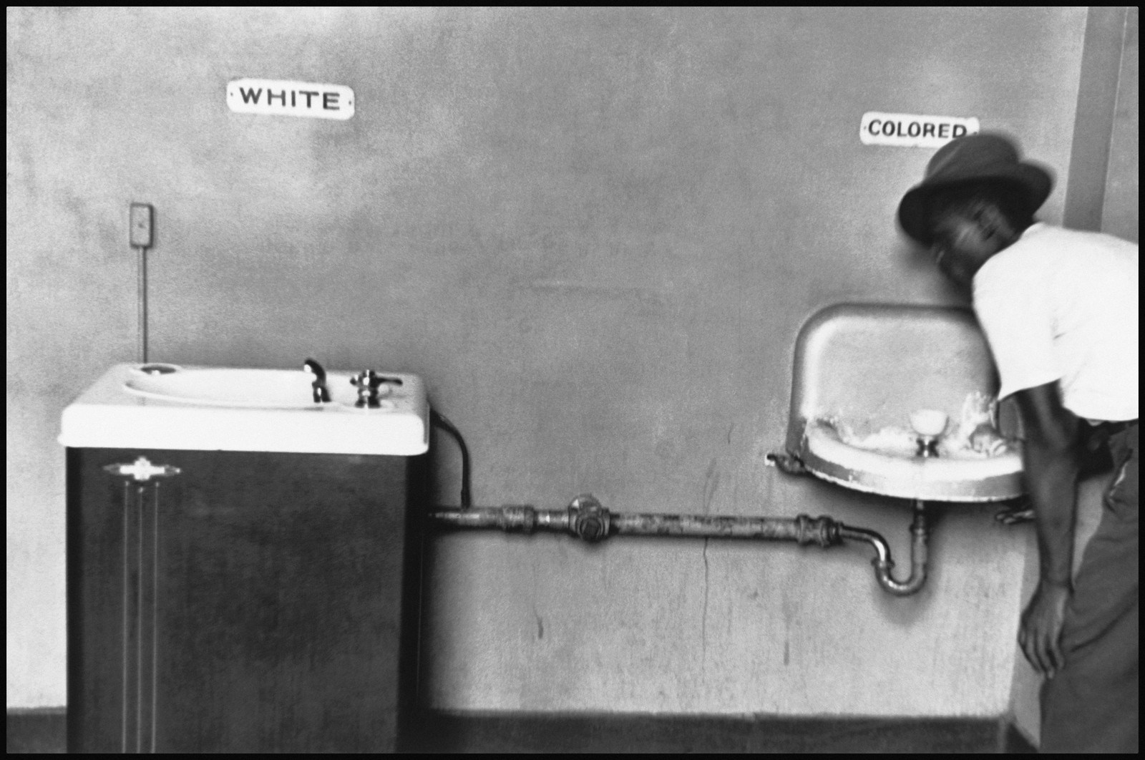
- American ____________________________ were not considered citizens until 1924.
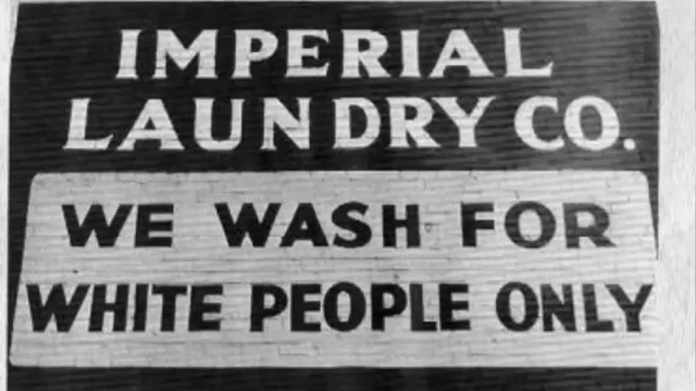

H. JIM CROW LAWS – How were African Americans discriminated against?
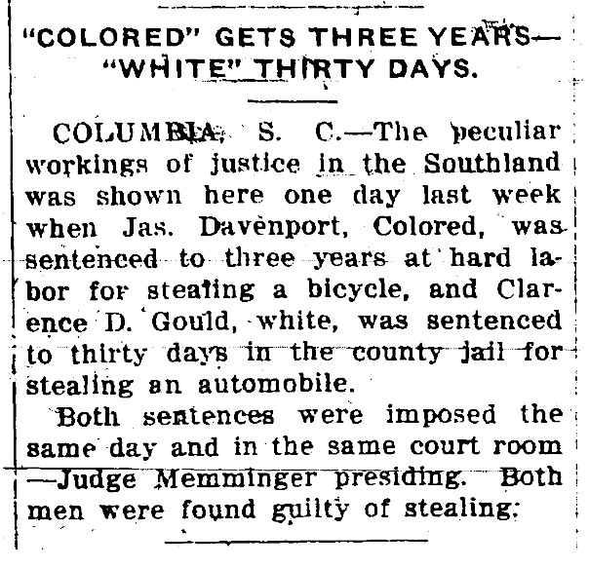
- Passed to ______________________ against African Americans.
- Made discrimination practices _____________ in many communities and states.
- Were characterized by unequal opportunities in ______________________, ____________________, ______________________________, and _______________________.
- Segregation was Upheld by the Supreme Court in __________________ vs. ____________________________
I. How did African Americans Respond to Jim Crow?

“The slave went free; stood a brief moment in the sun; then moved back again toward slavery.”

-W.E.B. DuBois
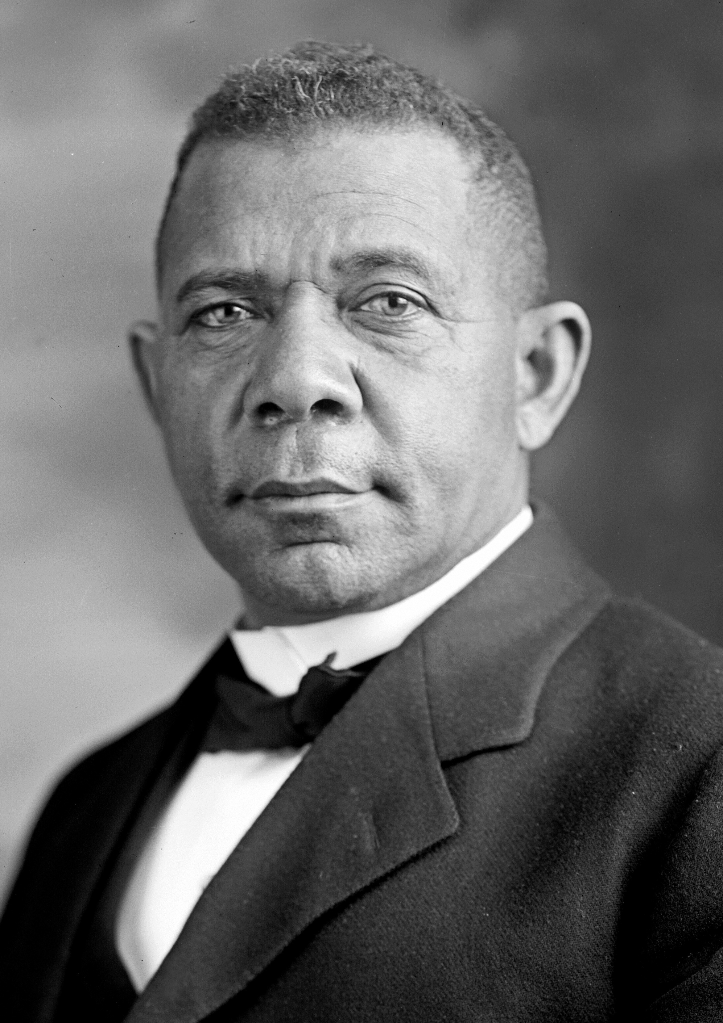
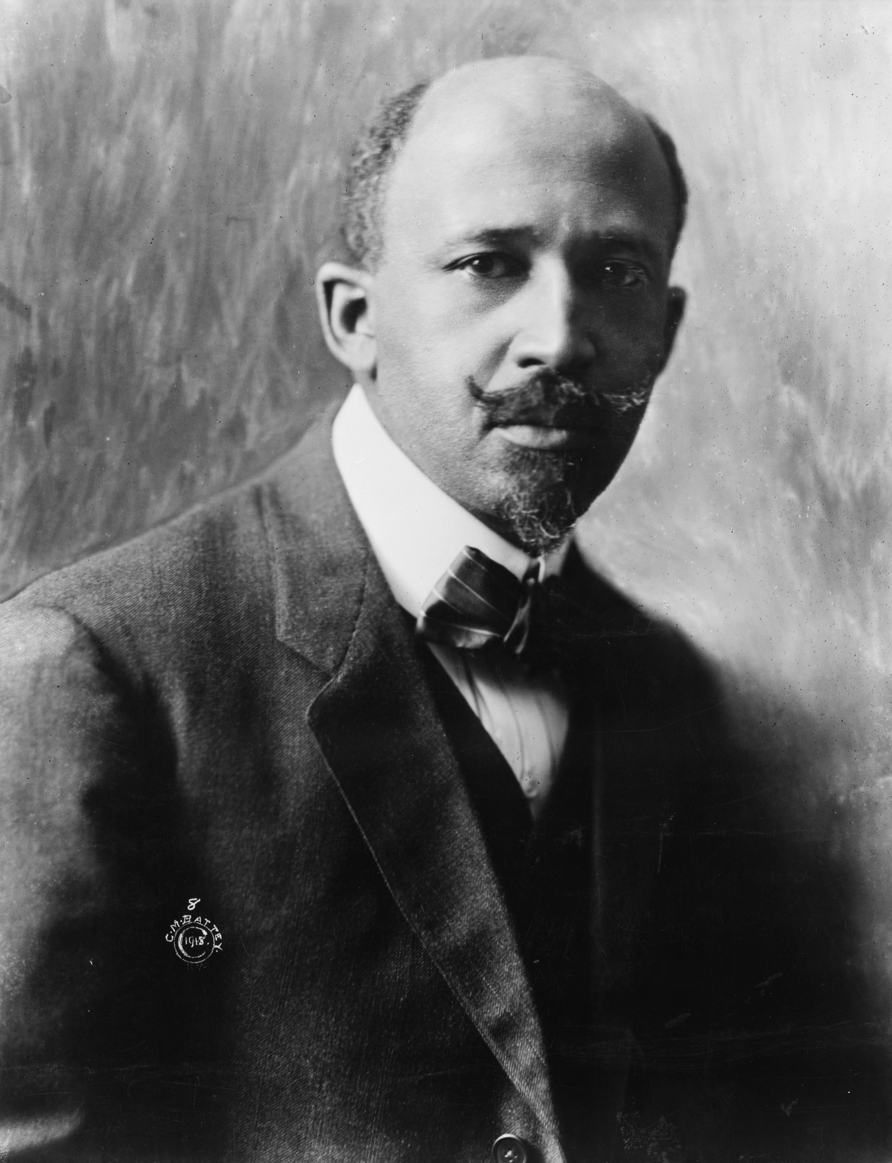
VS

Directions:
- Click on the “bio” links for a brief biography with videos on each leader’s response to Jim Crow.
- As you read/watch, complete the Venn diagram below.
- Make sure to include WHEN & WHERE each man was born, plus what type of education they had.
- Answer the discussion questions following the Venn diagram.

I. African American Response to Jim Crow Continued: Notes
Booker T. Washington

- Believed equality could be achieved through _________________ education.
- He _______________ social segregation as a way to improve the economic situation for African Americans.
- He had a _________________ approach to equality.

W.E.B. DuBois

- Believed in full ______________________, ________________, and __________________ rights for African Americans.
- He believed the ___________________________________ would lead African Americans in the fight for equality.
- One of the founders of the ____________ along with ____________________________________.
