WWII: Home Front

Vocabulary: Words to Know…

War Effort | Conservation | Rationing
Internment | War Bond | Victory Garden
Propaganda | Defense Plant | Exclusion

Essential Understandings:

- World War II affected every aspect of American life.

- Americans were asked to make sacrifices in support of the war effort and the ideals for which Americans fought.

H. How did Americans at home support the war effort?

- American involvement in WWII brought an end to the _________________________.
- ________________ and __________________ were needed to produce goods to win the war.
- Thousands of American __________________ took jobs in defense plants during the war.
  - Ex: ___________________________

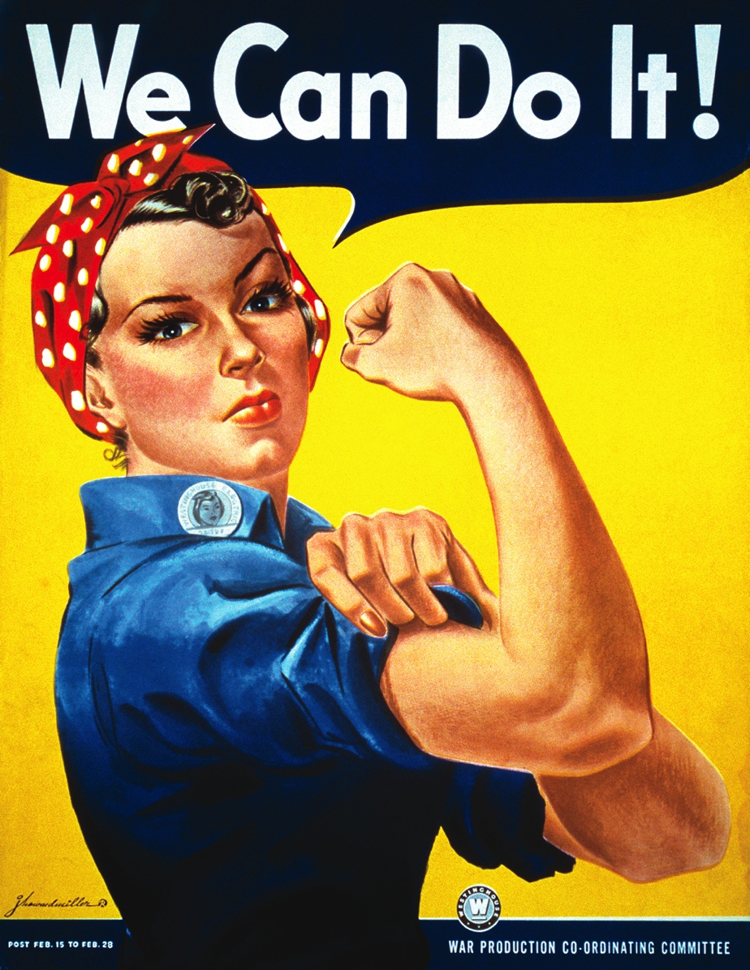

What was Rosie the Riveter?
________________________________________________________________________________________________________________________________________________________________________________________________________________________________________________

- Americans at home supported the war by ________________ and _______________ resources.

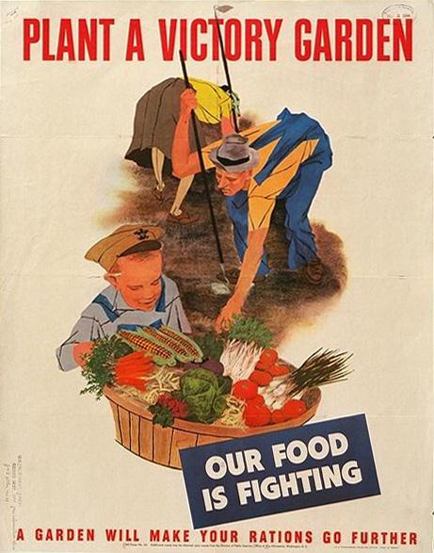
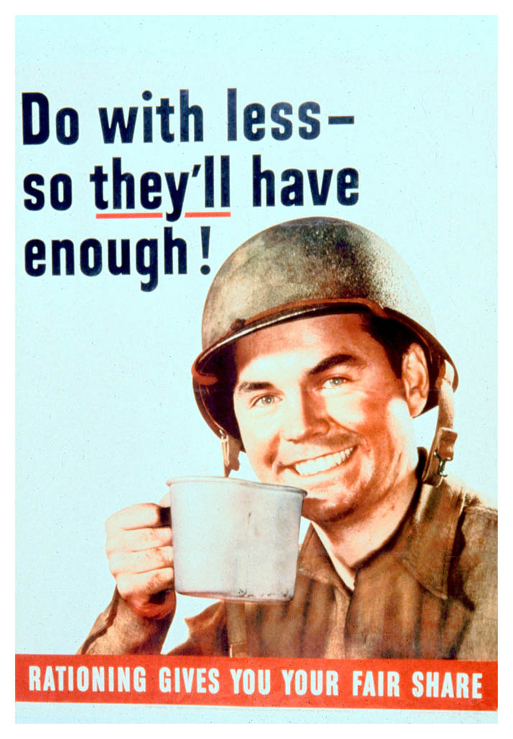
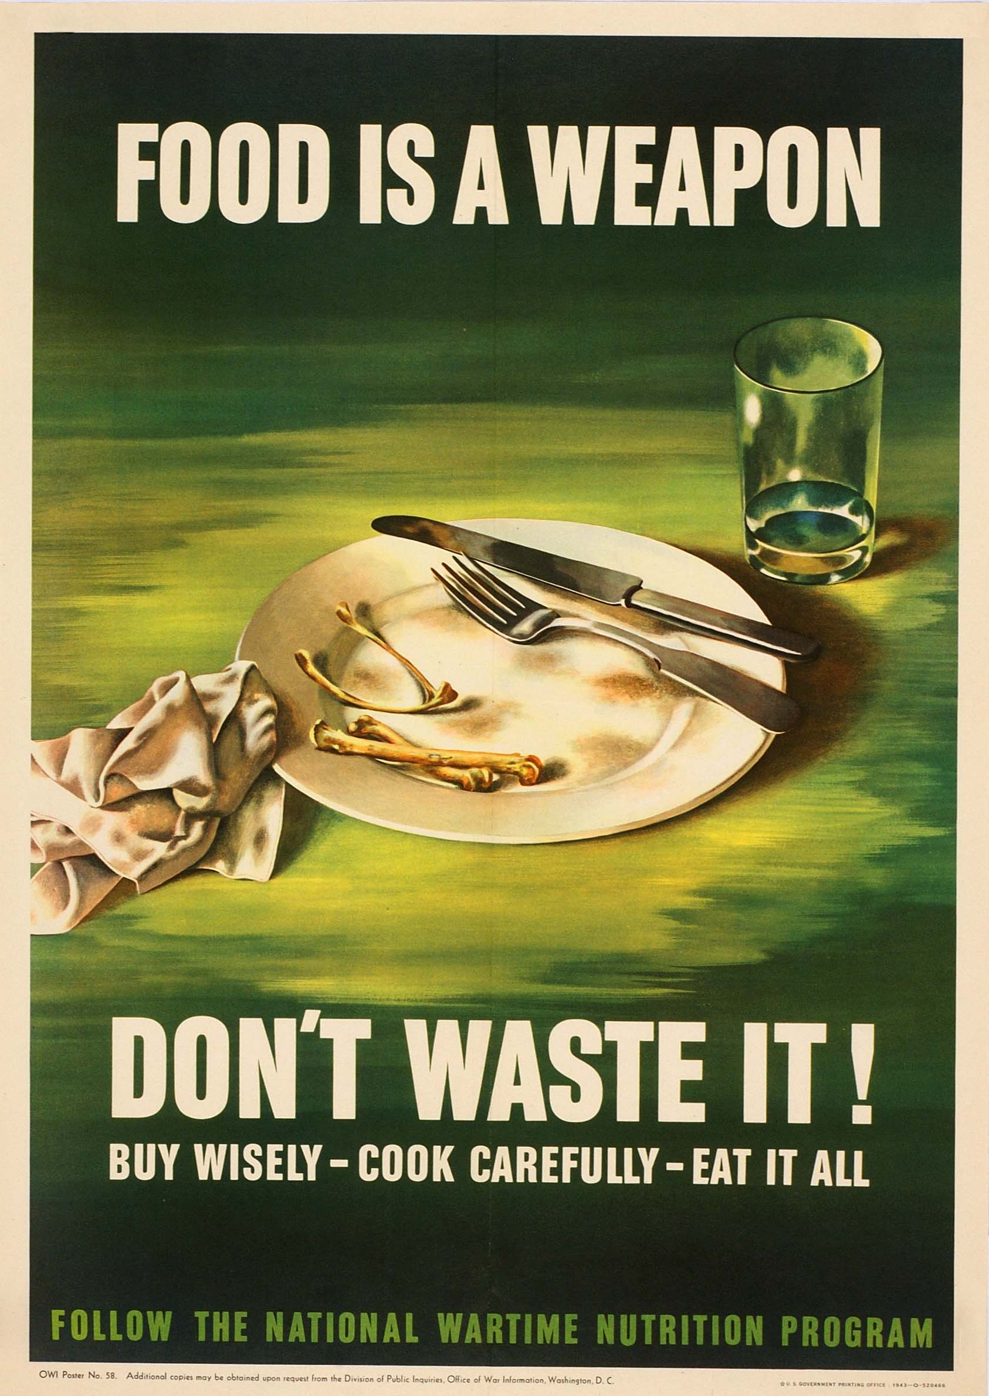
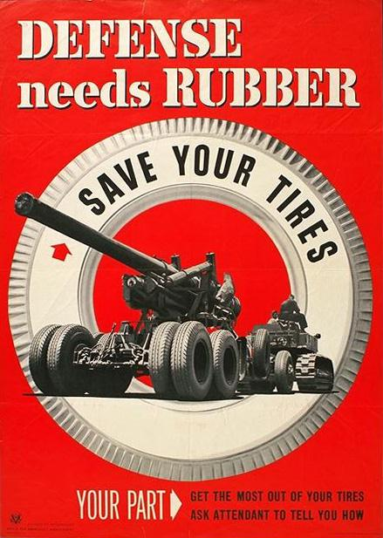

I. What Effect Did the War Have on Race Relations in America?

- The need for ____________ temporarily broke down some racial barriers, such as hiring in defense plants, although _____________________ against African Americans continued.
- More than ___________________ African Americans fought for the United States.

- The _________________ ______________ and other units became famous for their valor and skill.

- The service of African Americans in the war, especially against the racist Nazis, encouraged them to press for their ______________ in the United States.
- Despite their commitment and service, African Americans remained segregated in the armed forces until President Harry Truman ___________________ the armed forces in _________ during the ________________ War.
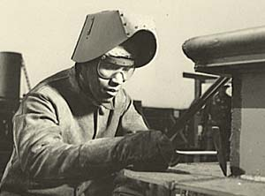
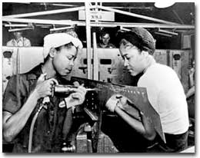

- While many Japanese Americans served in the armed forces, others were treated with ______________ and _______________, and MORE than 100,000 were forced into _______________________ _____________ in the United States.
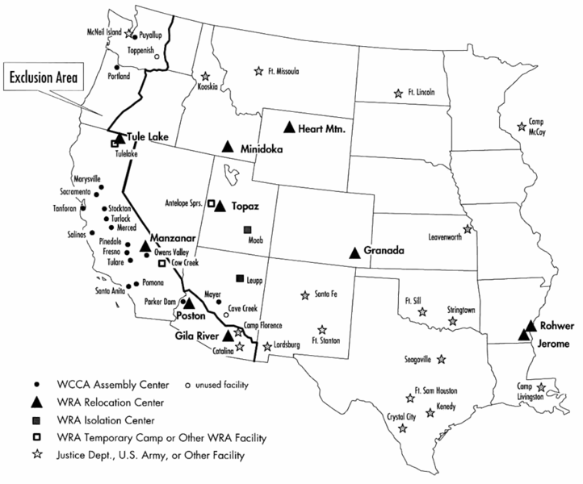
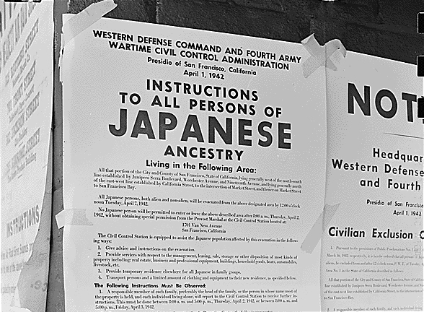

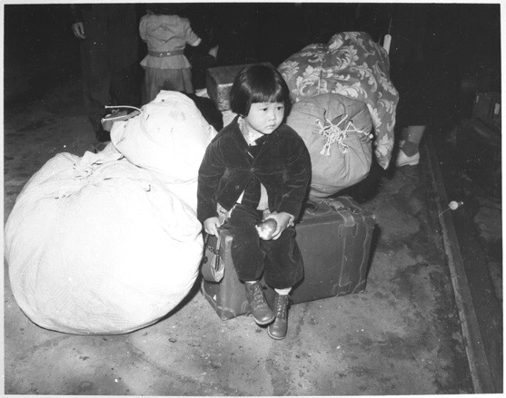

Why did the U.S. government move Japanese-Americans inland, off the Pacific coastline, to “undesirable” locations?
Will V-Day Be Me-Day Too?  by Langston Hughes  Over There,  World War II.  Dear Fellow Americans,  I write this letter  Hoping times will be better  When this war  Is through.  I'm a Tan-skinned Yank  Driving a tank.  I ask, WILL V-DAY  BE ME-DAY, TOO?  I wear a U. S. uniform.  I've done the enemy much harm,  I've driven back  The Germans and the Japs,  From Burma to the Rhine.  On every battle line,  I've dropped defeat  Into the Fascists' laps.  I am a Negro American  Out to defend my land  Army, Navy, Air Corps—  I am there.  I take munitions through,  I fight—or stevedore, too.  I face death the same as you do  Everywhere.  I've seen my buddy lying  Where he fell.  I've watched him dying  I promised him that I would try  To make our land a land  Where his son could be a man—  And there'd be no Jim Crow birds  Left in our sky. | So this is what I want to know:  When we see Victory's glow,  Will you still let old Jim Crow  Hold me back?  When all those foreign folks who've waited—  Italians, Chinese, Danes—are liberated.  Will I still be ill-fated  Because I'm black?  Here in my own, my native land,  Will the Jim Crow laws still stand?  Will Dixie lynch me still  When I return?  Or will you comrades in arms  From the factories and the farms,  Have learned what this war  Was fought for us to learn?  When I take off my uniform,  Will I be safe from harm—  Or will you do me  As the Germans did the Jews?  When I've helped this world to save,  Shall I still be color's slave?  Or will Victory change  Your antiquated views?  You can't say I didn't fight  To smash the Fascists' might.  You can't say I wasn't with you  in each battle.  As a soldier, and a friend.  When this war comes to an end,  Will you herd me in a Jim Crow car  Like cattle?  Or will you stand up like a man  At home and take your stand  For Democracy?  That's all I ask of you.  When we lay the guns away  To celebrate  Our Victory Day  WILL V-DAY BE ME-DAY, TOO?  That's what I want to know.  Sincerely,  GI Joe.

