THE GREAT MIGRATION

Dates of the Great Migration: from ________________ to ________________
Based on the following chart, what change in demographics took place in Northern & Midwestern Cities from 1910 – 1930? (demo = “people/populations”)
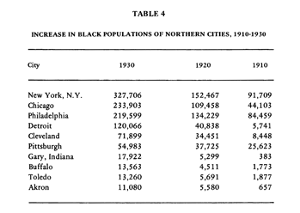
Change in demographics?

____________________________________________________________________________________________________________________________________________________________________________________________

Great Migration: Notes

- __________ for African Americans in the South were _______________ and _________ paying.
- African Americans faced _______________________ and _____________________ in the South.
- African Americans moved to cities in the _________________ and ___________________ in search of better ______________________ opportunities.
- African Americans also faced discrimination and violence in the _________________ and _____________________.
