Name: _________________________________ The Great Depression & New Deal

TIME PERIOD: The Great Depression began in the year ________________ and officially ended in the year _________________ with start of ________________________.

BACKGROUND INFO: Vocabulary

Terms | What does it mean? | Image…
Stock

Stock Speculators

Buying on a Margin

The Federal Reserve

Tariff

Foreclosure

Dust Bowl

Breadlines

Hoovervilles

The 3 R’s

Essential Understandings of the Great Depression:

- The optimism of the 1920’s concealed problems with the American economy.
- The Great Depression had a widespread and severe impact on American life.

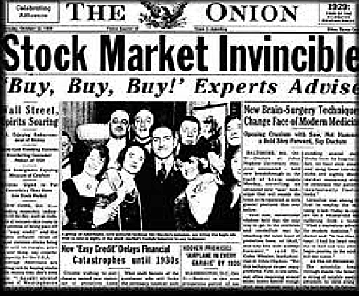
A. What were the causes of the Great Depression?
- People overspeculated on ____________, using borrowed _____________ that they could not repay when stock prices ______________.
- The Federal Reserve’s poor _________________ policies contributed to the ________________ of the banking system.
- High __________ discouraged international ___________.
- Many Americans had too much _____________ from buying ____________________ goods on installment plans

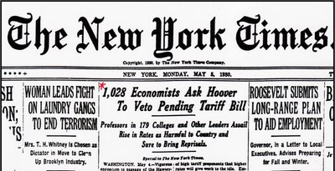

B. How did the Great Depression impact the lives of Americans?

- A large number of ______________ closed, and other ________________________ failed.

- _______________ of workers were without jobs. Unemployment rate = ______________________

- Large numbers of people were _______________ and ________________________.

- ________________ incomes fell to low levels.

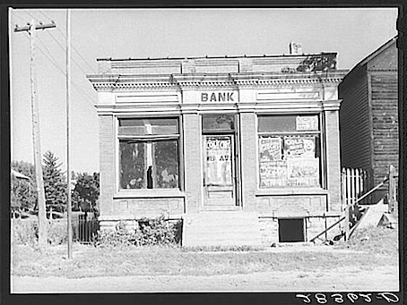

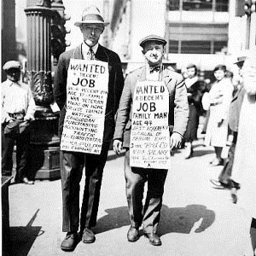

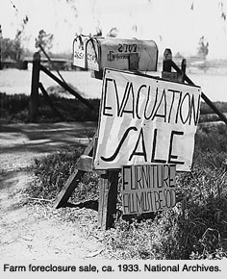
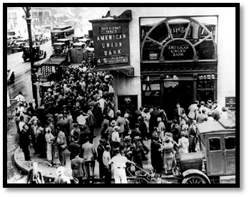

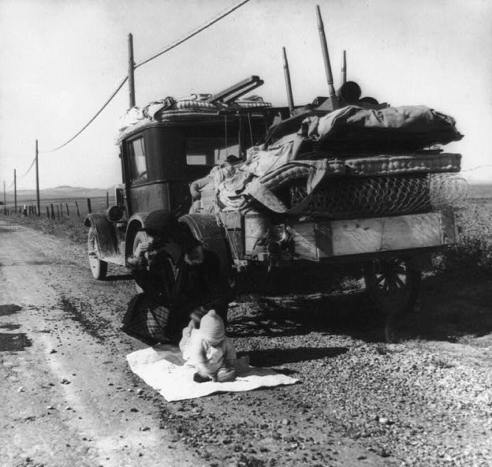
C. Major Features of the New Deal

“I pledge you, I pledge myself, to a new deal for the American people.” - FDR

- What president was elected to help bring the country out of the Great Depression? _______________________________________________________
- FDR’s inaugural address (speech) included the famous quote, “_________________________ ______________________________________________________________________” which was meant to motivate Americans to stop being afraid. If everyone worked together for the common good, they could bring America out of the Great Depression.

- The 3 R’s – ______________________, _____________________, and _______________________

- _______________________________________ – This program ensured that working Americans would have money available to live on when they become older and retired. (This is your SS#)

- _______________________________________ – Works Progress Administration (WPA) created jobs centered around public works projects such as construction or education needs.
- _______________________________________ – Civilian Conservation Corps (CCC), which focused on the conservation of natural resources along with protecting the environment.
- _______________________________________ – Agricultural Adjustment Act (AAA), which helped farmers who had lost income due to overproduction of crops, and worked with them to improve the quality of soil on their farms.
- _______________________________________ – Fair Labor Standards Act which set the standard work week at 40 hours, created a minimum wage for workers, and allowed workers to form labor unions.

How did the Great Depression end?

- Franklin D. Roosevelt’s New Deal used government programs to help the nation recover from the Great Depression. Even though the New Deal programs worked to improve the economy and the lives of all Americans, things were still tough!

- What officially brought America out of the Great Depression was…. _______________________

- Armies need war supplies to fight. American factories were ready to go when it came time to manufacture guns, tanks, planes, and every other weapon needed to defeat the AXIS powers of Germany, Japan, and Italy in WWII.

