Name: __________________________________ Cold War: Butter Battle Book

Question:
How does the story in Dr. Seuss’s “Butter Battle Book” parallel the major features of the Cold War?

Directions:
- Schoology: Watch the animated video Butter Battle Book located in the Unit 9: Cold War folder. (23:37)

- While watching the video, fill in your answers for the Butter Battle Book column. (pencil only)
- We will complete the Cold War column together as a class.

Questions: |  | Butter Battle Book | Cold War
Who is the conflict between? |  | ______________ vs. ______________ | ______________ vs. ______________
What is the original cause of the conflict?

How do they separate themselves in order to keep the other side out?

In what ways do “civilians” on each side make the situation worse?

Provide examples

What are some of the ways they show support for their own side of the conflict?

What happens when they try and defeat each other?

Why is there no “direct” conflict?

What do these images represent? (Cold War Equivalent)

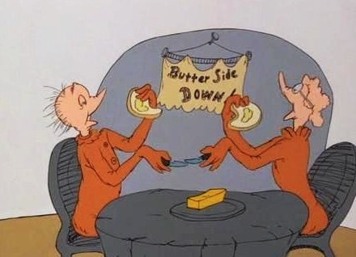

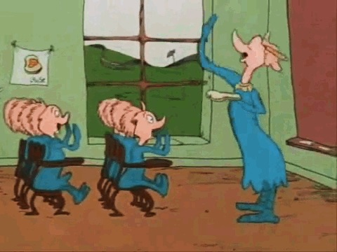

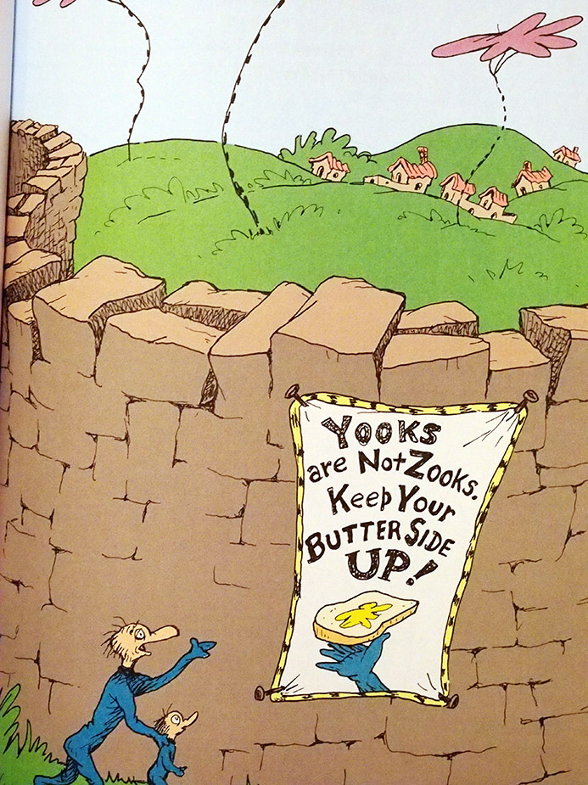

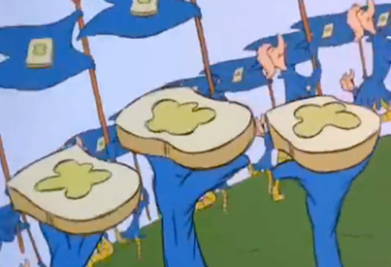

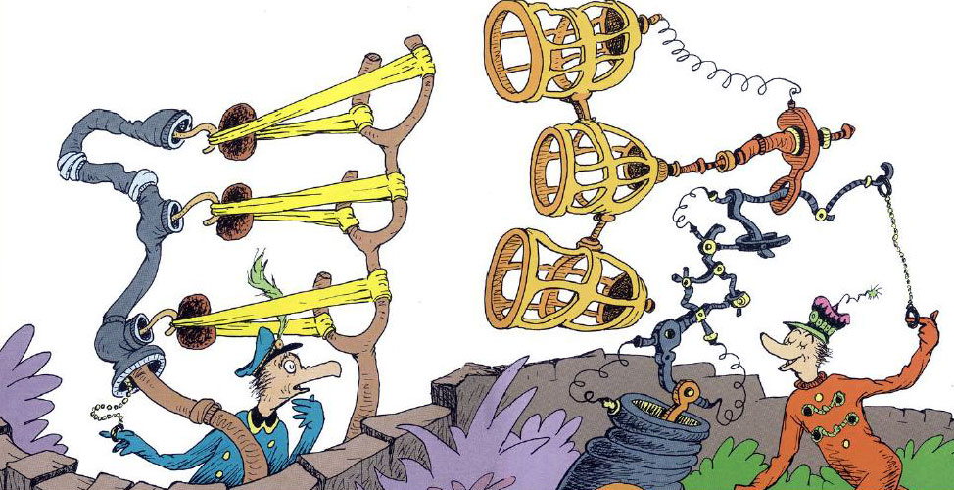 |  |  | What does this image represent?  How does the reaction of the character on the left represent the emotions of both Superpowers during the Cold War? (think about the NASA video from science)

