Name: \_\_\_\_\_\_\_\_\_\_\_\_\_\_\_\_\_\_\_\_\_\_\_\_ The American Dream K – N

Time Period: Post WWII – The Present

K. Factors that Lead to Changing Patterns in United States Society:

|  |  |  |
| --- | --- | --- |
| 1. |  | 💰 Strong \_\_\_\_\_\_\_\_\_\_\_\_\_\_\_\_\_\_\_\_\_\_\_\_\_\_\_\_\_  💰 Healthy \_\_\_\_\_\_\_\_\_\_\_ Market  💰\_\_\_\_\_\_\_\_\_\_\_\_\_\_\_ Productivity  💰\_\_\_\_\_\_\_\_\_\_\_\_\_\_\_ Demand for American Products |
| 2. | MC900439367[1] | 💰 A greater investment in \_\_\_\_\_\_\_\_\_\_\_\_\_\_\_\_\_\_\_\_\_\_\_\_\_\_\_\_\_\_\_\_ |
| 3. | 51sPyUpQh+L | **🚼** The \_\_\_\_\_\_\_\_\_\_\_\_\_\_\_\_\_\_\_\_\_\_\_\_\_\_\_\_ which led to changing \_\_\_\_\_\_\_\_\_\_\_\_\_\_\_\_\_\_\_\_\_\_\_\_\_\_\_\_\_\_\_\_ |
| 4. | MC900053326[1] | 🚘 Interstate \_\_\_\_\_\_\_\_\_\_\_\_\_\_\_\_\_\_\_ System |
| 5. | MC900360782[1]  MC900013564[1] | 🗘 Evolving role of \_\_\_\_\_\_\_\_\_\_\_\_\_\_\_\_\_\_\_\_\_\_\_\_\_\_\_\_\_\_  🗘 Expected to play a supporting role for the family while increasingly working outside the home. |
| 6. | 1783_cv3 | 🌍 Role of \_\_\_\_\_\_\_\_\_\_\_\_\_\_ \_\_\_\_\_\_\_\_\_\_\_\_\_\_\_\_\_\_ in expanding \_\_\_\_\_\_\_\_\_\_\_\_\_\_\_\_ rights |
| 7. | MC900155152[1] | 🕬 African Americans’ aspirations for \_\_\_\_\_\_\_\_\_\_\_\_\_\_\_ opportunities. |

L. Policies and Programs Expanding Educational and Employment Opportunities

|  |  |  |
| --- | --- | --- |
| 1. | Macintosh HD:Users:brownb:Desktop:1997.2.184_G._I._Bill_of_Rights.JPG | \_\_\_\_\_\_\_\_\_\_\_\_\_\_\_\_\_\_ gave \_\_\_\_\_\_\_\_\_\_\_\_, \_\_\_\_\_\_\_\_\_\_\_,  and \_\_\_\_\_\_\_\_\_\_\_\_\_\_ benefits to \_\_\_\_\_\_\_\_\_\_. |
| 2. | Macintosh HD:Users:brownb:Desktop:desegregation in military.jpg  Macintosh HD:Users:brookegreenberg:Desktop:imgres.jpg | In 1948, President Truman \_\_\_\_\_\_\_\_\_\_\_\_\_\_\_\_\_\_ the  United States Armed Forces. |
| 3. | Macintosh HD:Users:brookegreenberg:Desktop:VRA_cropped_blog_main_horizontal.jpg | Civil Rights legislation let to \_\_\_\_\_\_\_\_\_\_\_ educational, economic, and political opportunities for \_\_\_\_\_\_\_\_\_\_\_  and \_\_\_\_\_\_\_\_\_\_\_\_\_\_\_. |

M. GLOBALIZATION

* Globalization is the \_\_\_\_\_\_\_\_\_\_\_\_\_\_\_\_\_ of \_\_\_\_\_\_\_\_\_\_\_\_\_\_\_\_\_ through:
* \_\_\_\_\_\_\_\_\_\_\_\_\_\_\_\_\_\_\_\_\_\_
* \_\_\_\_\_\_\_\_\_\_\_\_\_\_\_\_\_\_\_\_\_\_
* \_\_\_\_\_\_\_\_\_\_\_\_\_\_\_\_\_\_\_\_\_\_
* \_\_\_\_\_\_\_\_\_\_\_\_\_\_\_\_\_\_\_\_\_\_
* Globalization involves increased \_\_\_\_\_\_\_\_\_\_\_\_\_\_\_ of different \_\_\_\_\_\_\_\_\_\_\_\_.

N. Impact of GLOBALIZATION on American Life:

* 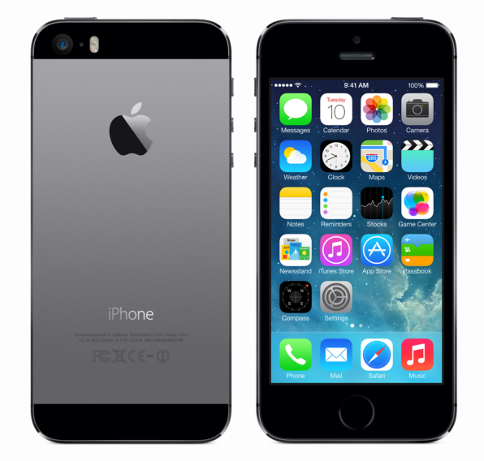Improvement of ALL \_\_\_\_\_\_\_\_\_\_\_\_\_\_\_\_\_\_\_\_\_\_\_:
  +  \_\_\_\_\_\_\_\_\_\_\_\_\_\_\_\_\_\_\_\_\_
  + \_\_\_\_\_\_\_\_\_\_\_\_\_\_\_\_\_\_\_\_\_
  + \_\_\_\_\_\_\_\_\_\_\_\_\_\_\_\_\_\_\_\_\_
* Availability of a wide variety of foreign-made \_\_\_\_\_\_\_\_\_\_ and \_\_\_\_\_\_\_\_\_\_\_\_

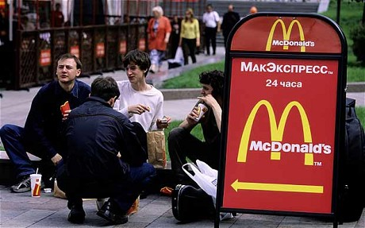



* 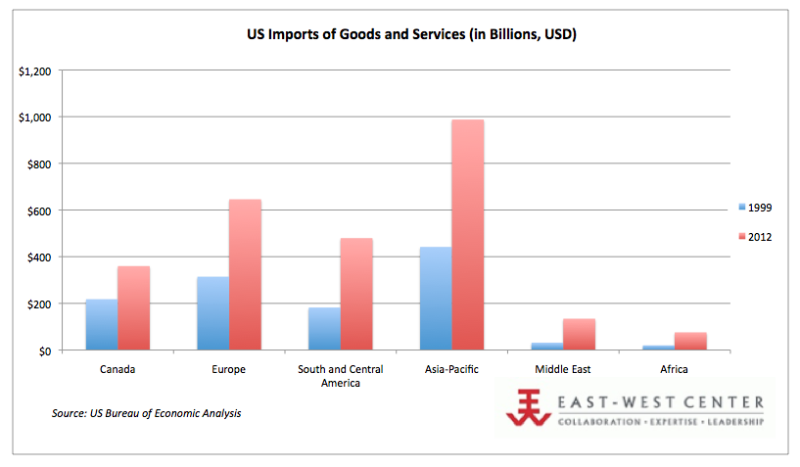Outsourcing of American \_\_\_\_\_\_\_\_\_\_\_\_