Name: _________________________________ The Marshall Plan A - C

Vocabulary:

Superpower | Occupation | Communism
Partitioned | Domination | Democratic
Self-government | Marshall Plan | United Nations
Credit (buying on credit)

Part 1. Essential Questions

1. How did the United States help rebuild postwar Europe and Japan?
__________________________________________________________________________________________________________________________________________________________________________________________________________________________________________________________________________________________________________________________________________________________________________________________________________________________________________________________________

A. Rebuilding Efforts – EUROPE

1. Much of Europe was left in __________ following WWII. ___________ forces occupied most of __________________ and _________________ Europe and the ______________ portion of Germany. The _______________________________ felt it was in its best interest to help _______________ Europe and prevent __________________ and _________________ instability.

2. The United States instituted Secretary of State George C. Marshall’s plan to __________ Europe called the _________________________, which provided massive _________________aid to rebuild European _____________________ and prevent the spread of _____________________.

3. ___________________ was partitioned into ____________ and _______________ ________________.

4. West Germany became ______________________ and resumed _________________________ after a few years of American, British, and French occupation.

5. East Germany remained under the domination of the __________________________ and did NOT adopt ___________________ institutions.
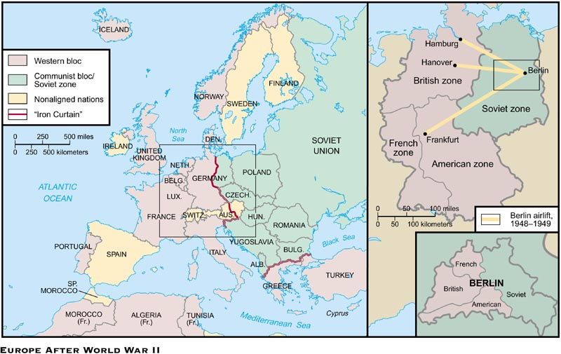

B. Rebuilding Efforts – JAPAN

1. Following its defeat, Japan was occupied by ___________________ forces.

2. It soon adopted a _______________________ form of government.

3. Soon after, they resumed ________________________________.

3. Japan became a strong ________________ of the United States.

C. Establishment of the United Nations

1. The United Nations was formed _____________________ of World War II to create a body for the nations of the world to prevent future global _______________.

