Niharika and Vishakha

**THE DAILY NEWekwkS**

Since 1850

YOUR DAILY FAVOURITE NEWSPAPER

**SPAIN BRUTALLY BRINGS THE WRATH OF USS MAINE**

Farewell to the USS Maine and Hello to War With Spain

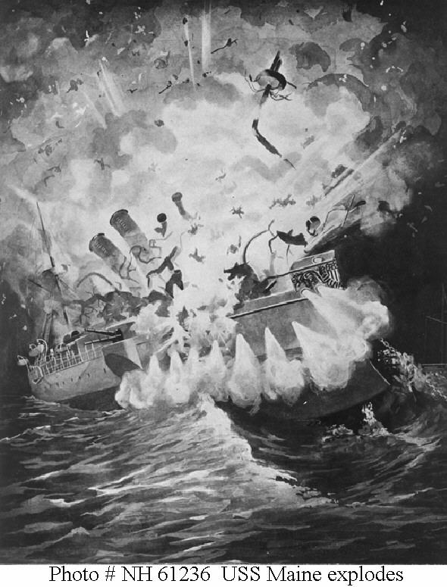

**The Last Day for the USS Maine...**

Yesterday February 15, 1898 , the USS Maine took it’s last breaths in Havana Harbor. The ship mysteriously exploded at precisely 9:40 p.m. More than 250 men were brutally killed, or....murdered? Only 89 of the people aboard survived the massive explosion. The USS Maine was a ship that will always stay in the hearts of America.

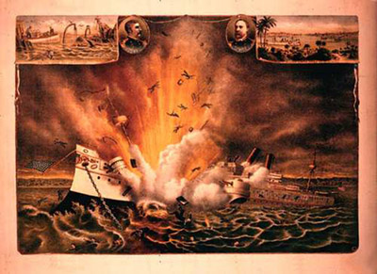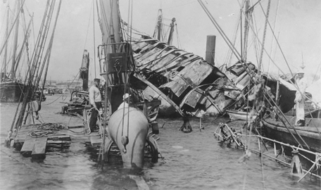

**America VS. Spain**

Tensions were already staring between the US and Spain. After riots occured in Havanna Harbor, President McKinley sent a ship to protect the situation, not to kill his men. America would not have standed Spain trying to burn their Sugar Canes, would they? After all, Cuba was part of America, and Spain had no right over it.

**The Beginning of a War?**

Not long after the ship exploded, the US pointed their fingers towards Spain for the wreckage of the USS Maine. This was obviously one of Spain’s clever tricks! We are not going to sit around and let Spain rule, are we? Or are we going to fight them with our souls? **“Remember the Maine! To Hell with Spain!”** They take our Maine, we take control of Spain! Is that not right? They *will* have to pay for the actions they have took!

