Immigration & the Growth of Cities A-F

Background Vocabulary:

Rural - _________________________________________________________________________________
Urban - ________________________________________________________________________________

Definition of the suffix “-ization” = __________________________________________________________________

Define the following terms that describe the Growth of America:

URBANIZATION - __________________________________________________________________________________
MECHANIZATION - ________________________________________________________________________________
INDUSTRIALIZATION - ______________________________________________________________________________

A. Reasons for Increase in Immigration:
Rise in Immigration

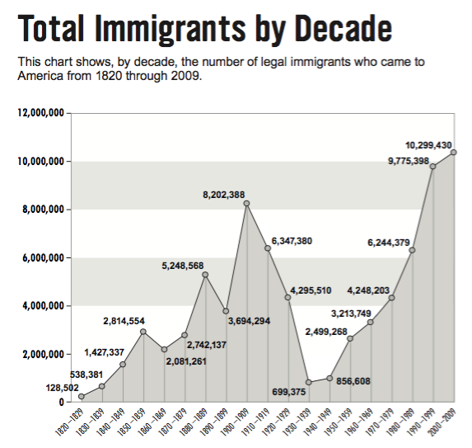

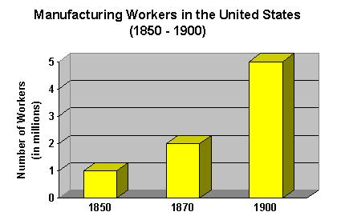

B. Reasons why cities grew and developed:

1. ______________________ industries, including _______________ in  Pittsburgh, _________ packing in Chicago, and __________________  In Detroit. |       
2. ___________________________ to America from other countries. |   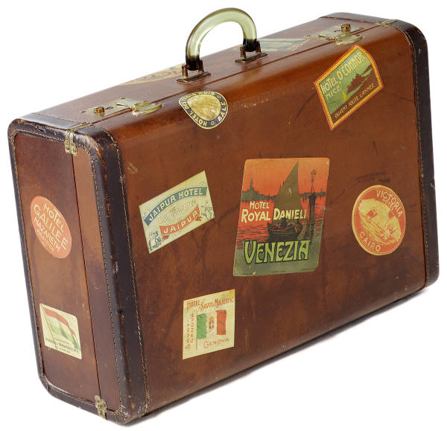  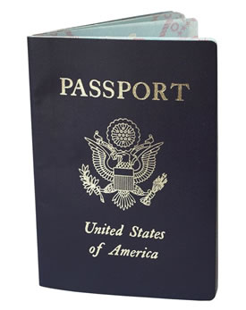
3. Movement of Americans from ___________ to _______________  areas for _________ opportunities.  What caused farm workers to lose their jobs in rural areas?  _________________________________________________________ | 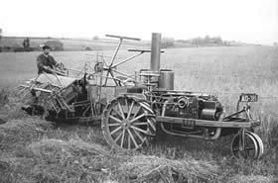

C. Negative Impact of Urbanization:

How could rapid growth of cities such as New York be bad?

Rapid ______________________ and ________________________ led to _________________________ immigrant __________________________ and ___________________________.

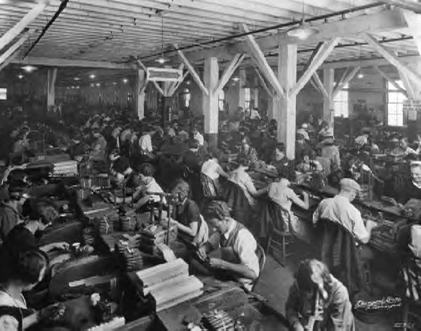
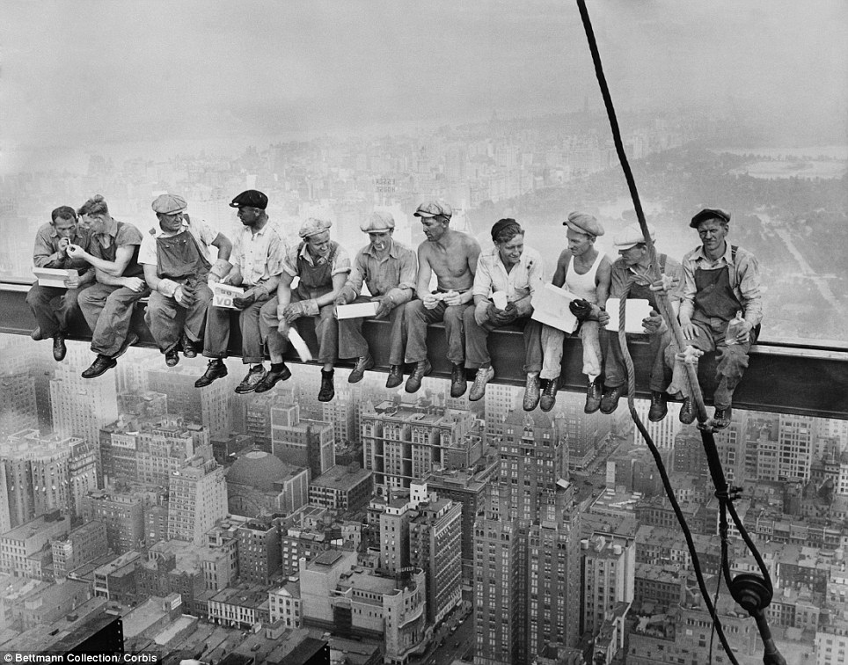
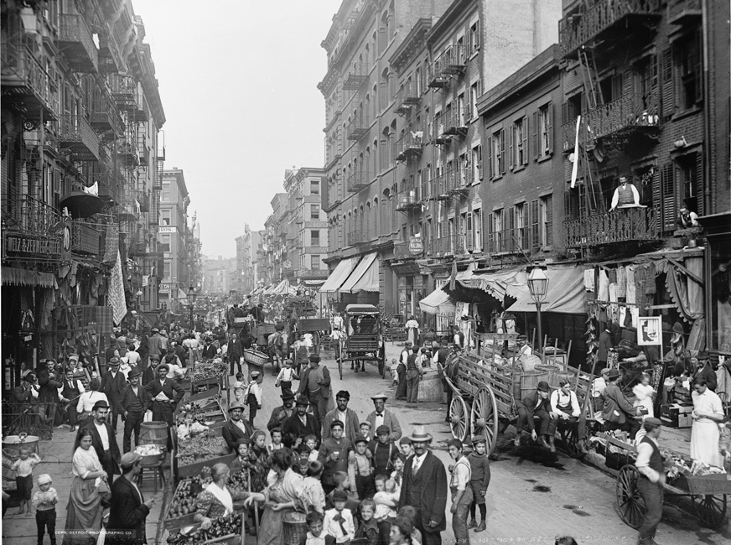
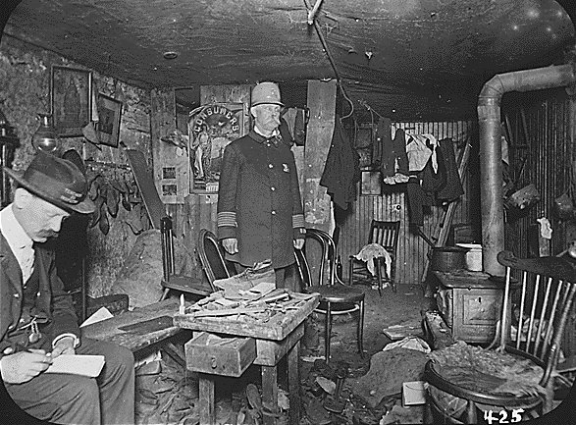

D. Efforts to Solve Immigration Problems:

Efforts |  | Image that comes to mind…
1. | ______________________ _____________, such as  the ___________ ______________ founded by  ___________ ____________.
2. | _________________ ________________ that gained  _________________ by attending to the _______________ of  new ____________________________.  Ex. __________ and _________________

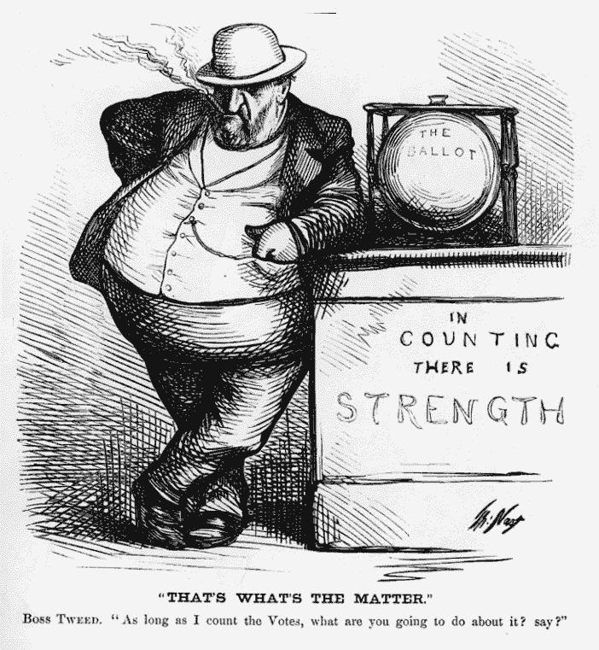
E. Discrimination Against Immigrants:

“Which immigrant groups faced the most
discrimination living in the United States?”

- ___________________________________________
- ___________________________________________
- ___________________________________________
- ___________________________________________
- ___________________________________________
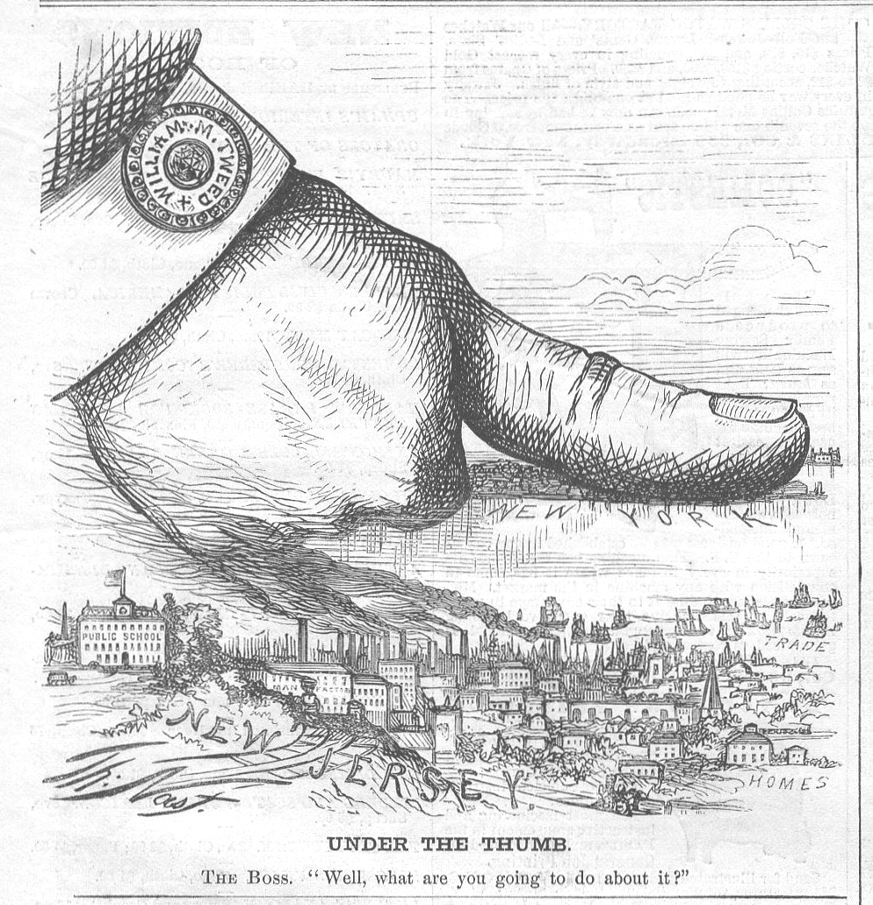

What did Americans of English decent refer to themselves as? (hint: ironic name)

“______________________________________”

F. Challenges Faced by Cities:

“What challenges developed due to the rapid growth
and development of cities such as New York and Chicago?”

1. __________________________ & ___________________________

2. __________________ _____________________________________
from political machines such as Tammany Hall (Boss Tweed)

