Name: ____________________________ Civil Rights Movement A-C

How did the law support the struggle for equality for African Americans?

______________________________________________________________________________________________________________________________________________________________________________________________________________________________________________________________________________

Background Information: How did segregation become legal in the United States?

Court Case: ____________________________ vs. ________________________________
Outcome: ________________________________________________________________________________
When: _________________
Description: ______________________________________________________________________________ ____________________________________________________________________________________________________________________________________________________________________________________
A. Effects of Segregation:

- Separate _______________ facilities and resources for white and African American students.
- Separate ___________ facilities, such as _______________, _______________________________, ____________________.
- _______________ Isolation of Races.

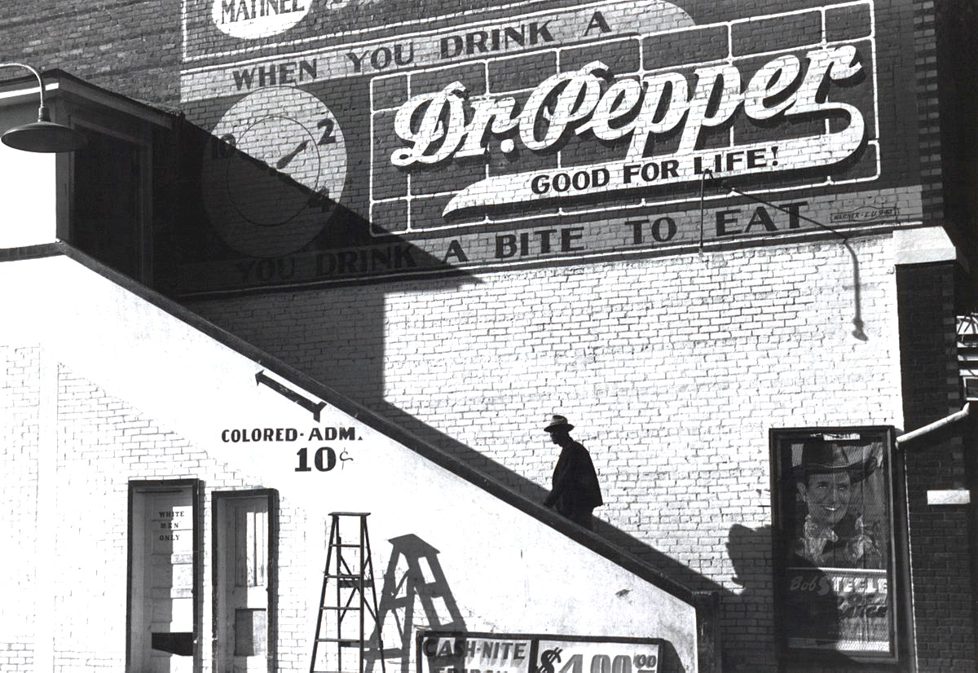
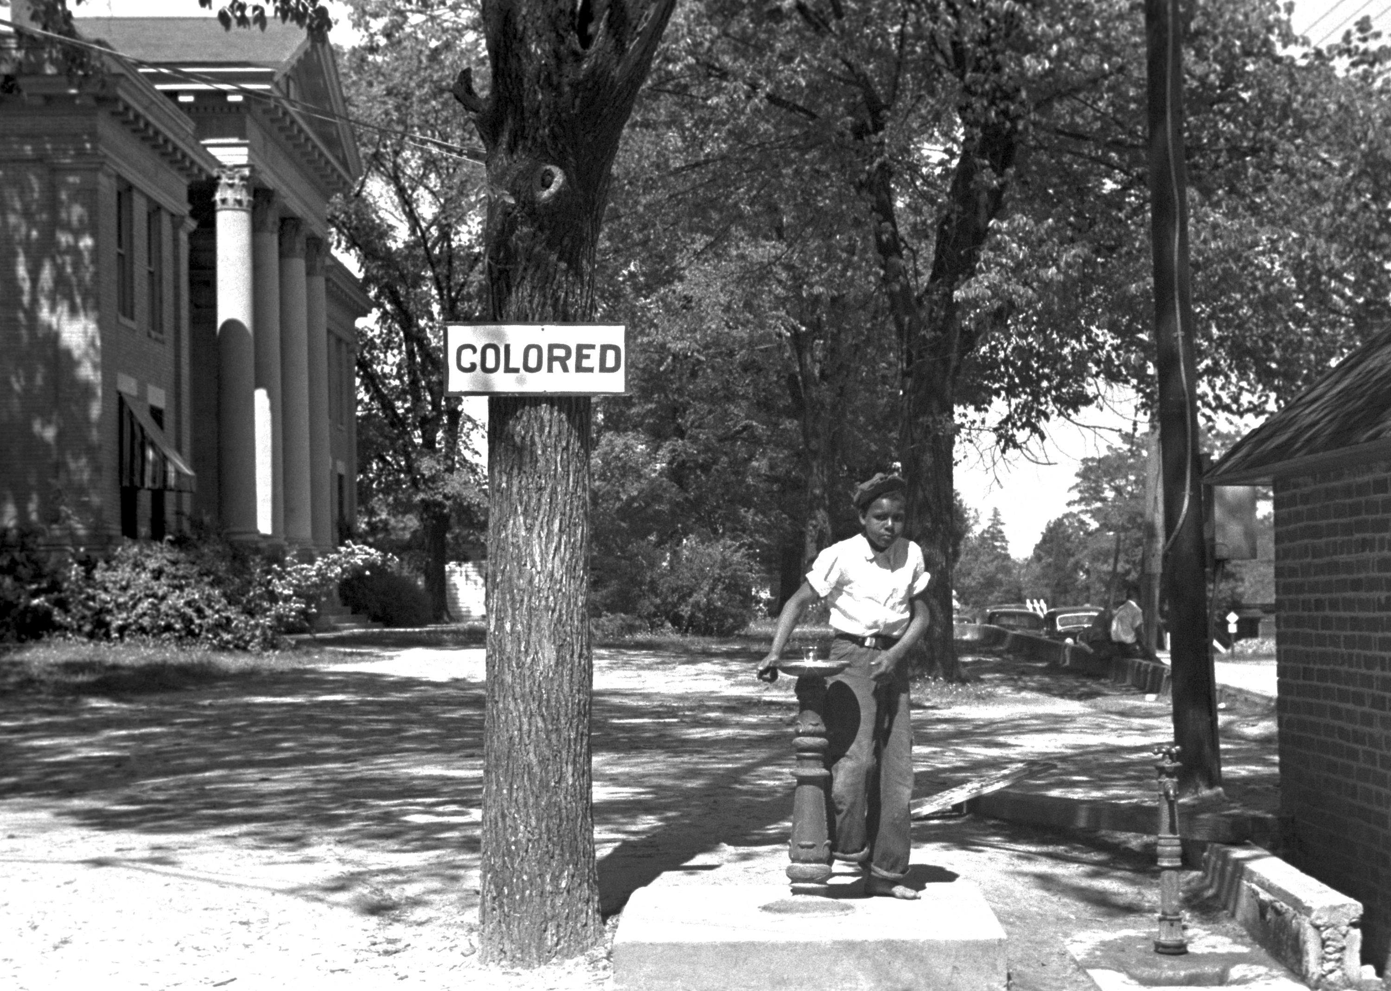

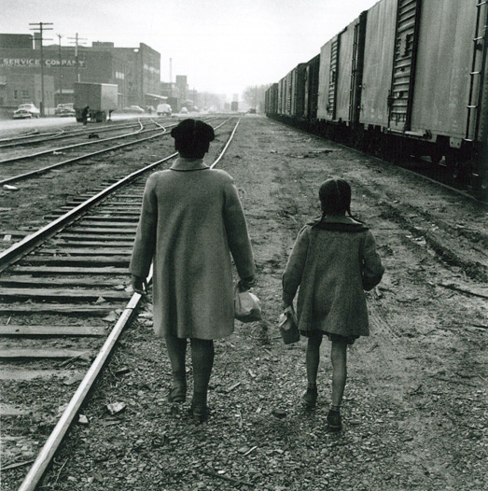
B. The Civil Rights Movement: 1955 – 1968

1. ______________________ to Plessy vs. Ferguson
- “ Separate but ________ Equal”
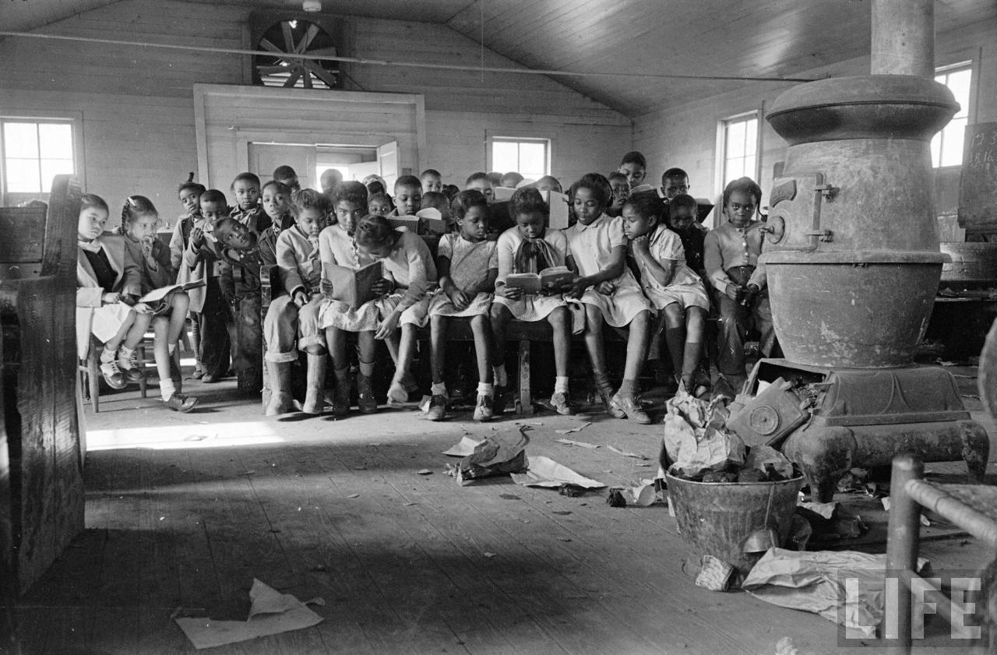
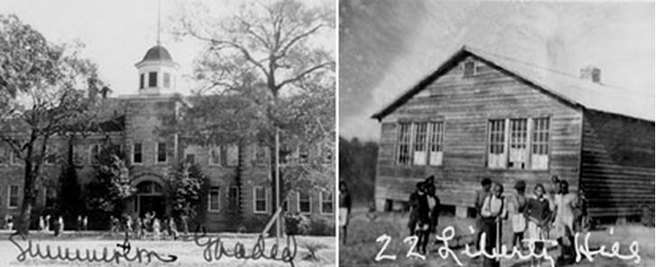

2. Desegregation of _______________________
Court Case: ____________________ vs. _________________________________________________
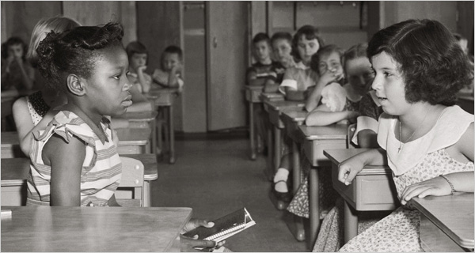
When: _______________
Outcome: _______________________________________ ___________________________________________________________________________________________________________________________________________________

3. ________________________________________________________ When: ____________
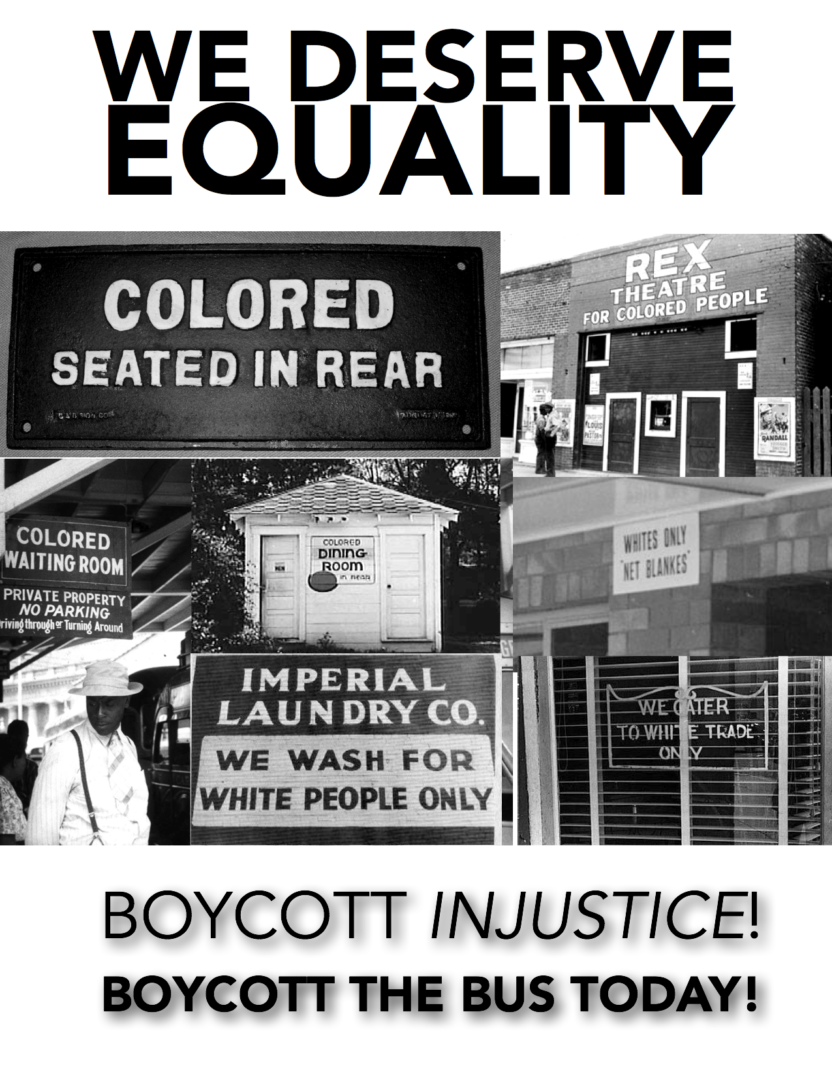
- In response to _____________ being arrested after refusing to give up her seat on a segregated bus in Montgomery, Alabama.
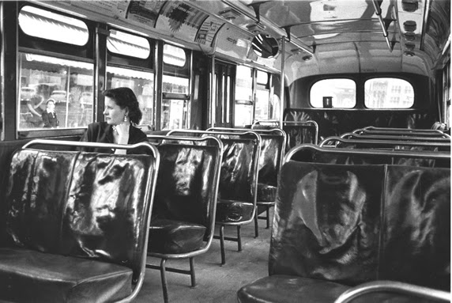
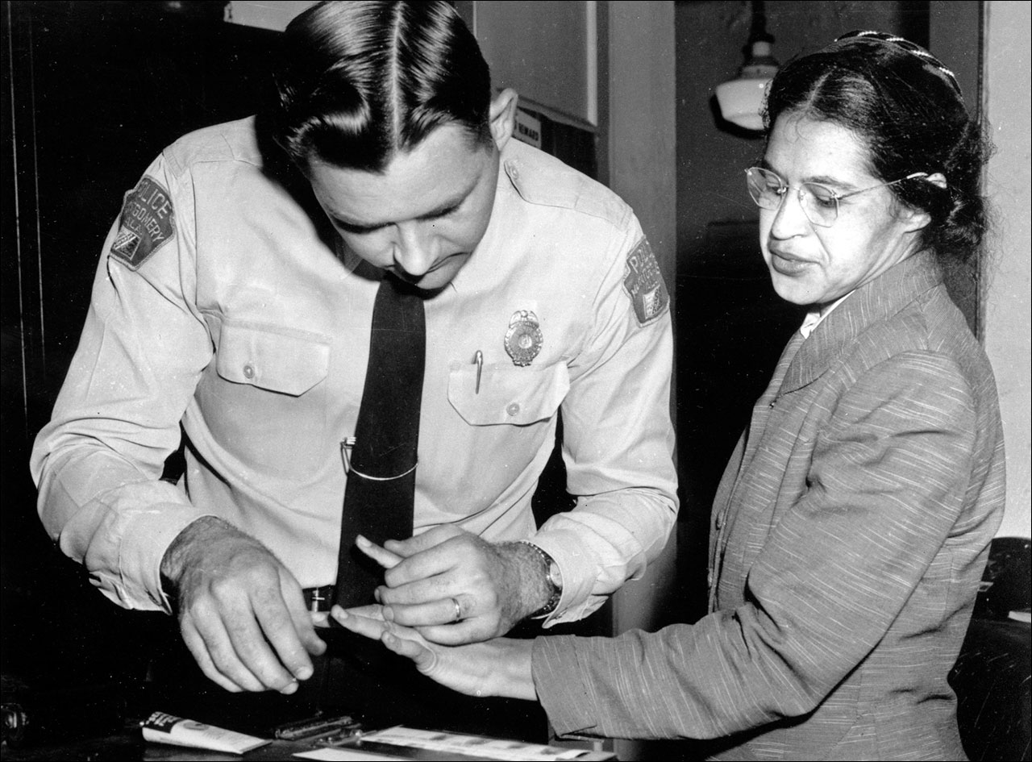

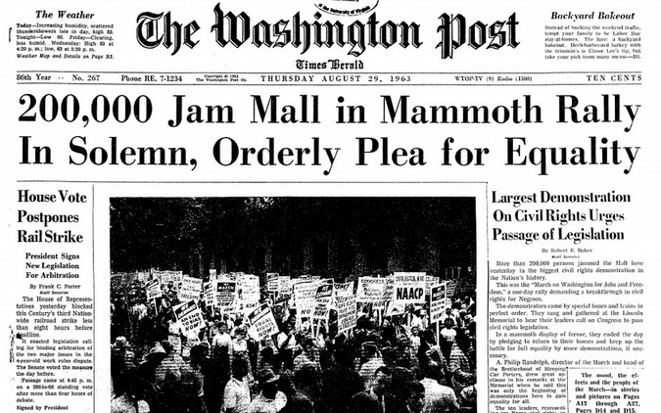
4. _______________________________________________
- Passive Resistance Against __________________ Facilities
- Passive Resistance = ________________________________

- On August 28, 1963, during the March on Washington, he gave his famous, “_____________________________________________________________________” speech.
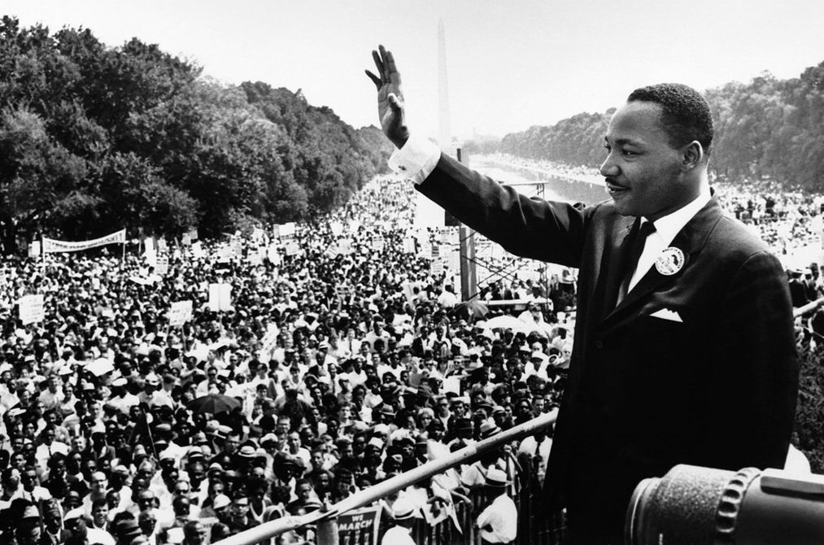
“I have a dream that one day this nation will rise up and live out the true meaning of its creed, “We hold these truths to be self-evident, that all men are created equal.” I have a dream that one day on the red hills of Georgia, sons of former slaves and the sons of former slave owners will be able to sit down together at the table of brotherhood. I have a dream that one day even the state of Mississippi, a state sweltering with the heat of injustice, sweltering with the heat of oppression, will be transformed into an oasis of freedom and justice. I have a dream that my four little children will one day live in a nation where they will not be judged by the color of their skin but by the content of their character.”
- Martin Luther King Jr.

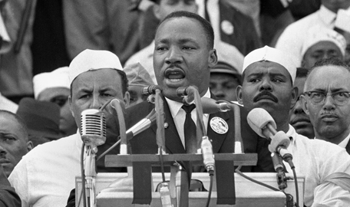

5. Expansion of the ____________________________________
Originally founded by _______________________________ in ________________.

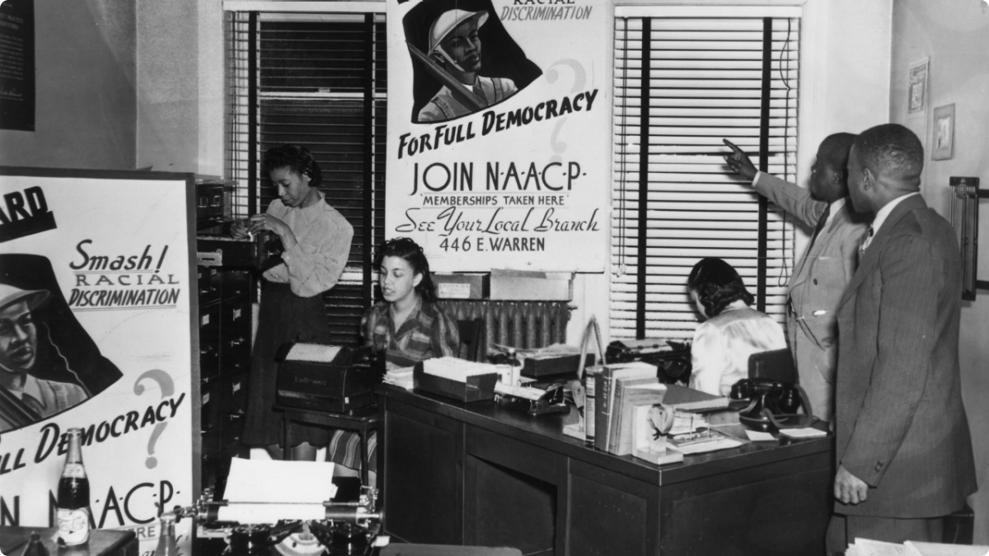
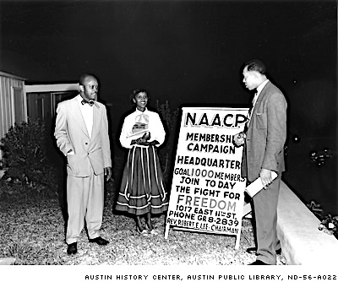

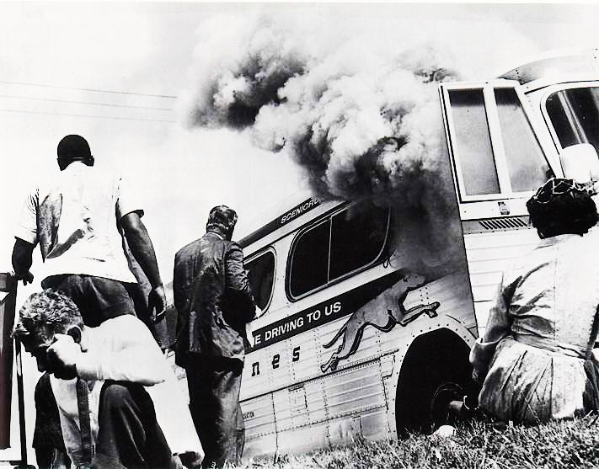
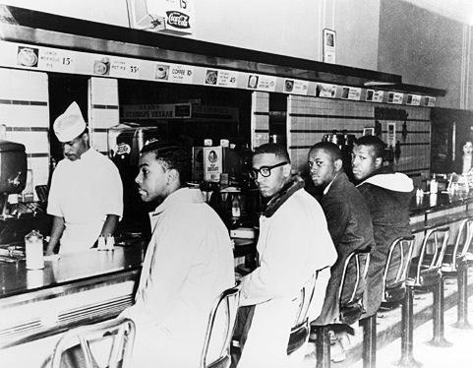
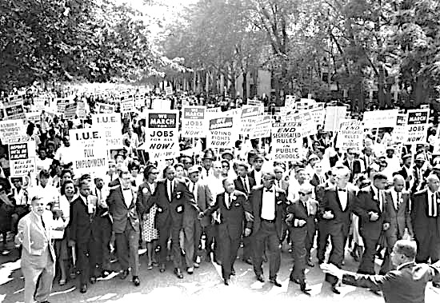

6. Organized Protests:

a. ____________________________________________
What were they protesting? ________________________________________________________________
How did they protest? _____________________________________________________________________ ____________________________________________________________________________________________________________________________________________________________________________________
Outcome: ________________________________________________________________________________

b. ___________________________________________
Examples: ________________________________________ & _____________________________________
What were they protesting? ________________________________________________________________
How did they protest? _____________________________________________________________________ ____________________________________________________________________________________________________________________________________________________________________________________
Outcome: ________________________________________________________________________________

c. ____________________________________________
Examples: _______________________________________________________________________________
_________________________________________________________________________________________

7. Civil Rights Act of _____________________
- Signed by President ______________________________________________________
- Prohibited discrimination against African Americans in _____________________, ________________, and ___________________ accommodations. It banned discrimination not only by race or color, but also by gender, religion, or national origin (where you are from).
8. Voting Rights Act of ___________________________

- Signed by President _____________________________________________________________
- This gave the __________________ government the power to _______________ local officials in the _________________ to allow African Americans to _______________________ to vote.

C. Changing Role of Women:

How were women disadvantaged in the workplace?
____________________________________________________________________________________________________________________________________________________________________________________

What actions were taken to improve conditions for women?
____________________________________________________________________________________________________________________________________________________________________________________

a. Workplace Disadvantages:

- The 19th Amendment gave women the _________________________ but things still weren’t “equal” in America.
- Women faced disadvantages in the workplace such as:
Discrimination in the _______________ process
____________wages for women than for __________ doing the _________ job.

b. Improved Conditions:
  - NOW: _______________________________________ fought for women’s rights.
  - Federal Legislation to force colleges to give women equal _________ opportunities

c. Equal Rights Amendment (ERA):
- The ERA, despite its ___________, and a focus on equal opportunity employment, created a wider range of _____________ and ______________________ for women in _______________ and ______________ service.

