Name: ____________________________________ Causes of World War II
Vocabulary:
- Fascism  - Inflation  - Dictator | - Nationalism  - Racism  - Neutrality | - Isolationism  - Lend-Lease Act  - Axis Powers  - Allied Powers
Essential Understandings:
- Political and economic conditions in Europe following World War I, led to the rise of fascism and World War II.
- The rise of fascism threatened peace in Europe and Asia.
- As conflict grew in Europe and Asia, American foreign policy evolved from neutrality to direct involvement.

- Causes of World War II

  - ________________ instability and __________________ devastation in Europe resulting from WWI:
    - Worldwide _____________________
    - High war ______________ owed by Germany
    - High _______________________
    - Massive _________________________

- Political instability led to the rise of ______________________
1. What is Fascism?
  - A political philosophy in which TOTAL power is given to a _____________________
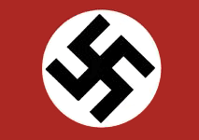
  - Individual freedoms are denied and ______________________, often along with _______________________, are emphasized.
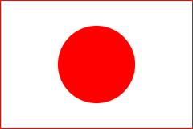
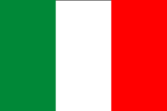

+
+
=
Country: ________________
Leader: _________________
Country: ________________
Leader: _________________
Country: ________________
Leader: _________________

      - _______________________ Nations = __________________ Powers
Country: ________________
Leader: _________________
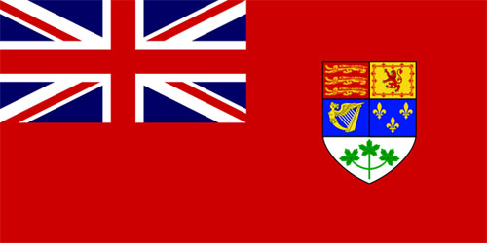
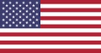
Country: ________________
Leader(s): _______________
& ________________________
+
+
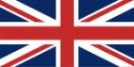
Country: ________________
Leader: _________________

=
+

Country: _____________
A self-governing dominion of Great Britain, who share the same monarch (King George VI during WWII)

+

- Which of the above allied countries was NOT a democratic nation? __________________________
- When did they join the Allies? ___________________________________________________________ _______________________________________________________________________________________
- Which Allied leaders were known as the “Big Three”? _____________________________________ _______________________________________________________________________________________

      - Gradual change in American policy from neutrality to direct involvement:
- As conflict grew in Europe and Asia, American foreign policy evolved from _________________ to ______________ involvement.

________________________________________________________________________________________________
Image:
________________________________________________________________________________________________
Image:
________________________________________________________________________________________________
Image:

E. America is now fighting a war on ______ FRONTS:
Your notes begin on the slide labeled “NOTES”

- Rising ____________________ between the U.S. and Japan because of Japanese ______________________ in ______________________________.
December 7, 1941:
  - Japan attacked the United States at _________________________ without warning
December 8, 1941:
  - The United States declares war on ________________________
December 11, 1941:
  - Germany declares war on the United States
Hours later….
  - The United States declares war on _________________________

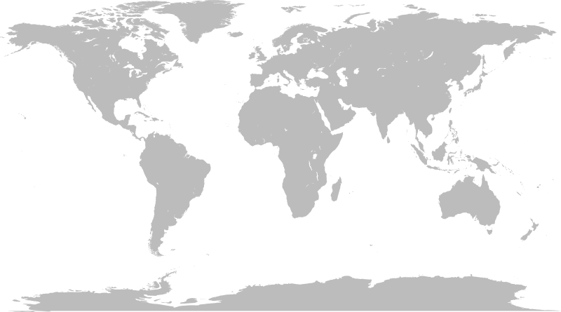
Circle the two geographic locations of WWII:

